Dapresy Cross table
user manual

Contents
Dapresy Cross table 1
Cross table 5
Step by step – create new cross table 5
Additional Options 7
Position the Questions 7
Step by step – Move, transpose, clear question selection 7
Select the Answers for the Questions and Splits 9
Add Totals and Subtotals Splits 9
How to add filter to Cross table 12
Categorical Filters and Hierarchical Filters 12
Step by step-adding filters to Cross table 12
Hierarchical filter in Cross table 14
Generate cross table 14
Calculations in Cross table 17
Calculation types 17
Standard Calculations panel 17
Correlation Analysis 18
Step by step – correlation analysis 18
Significance Testing 20
Step by step-significance testing 20
Additional Options 22
Visualize Significance Test with Colored Values 22
Benchmarks 24
Step by step – using benchmarks 24
Additional Options 25
Settings in Cross table 25
Additional Options 28
My favorites in Cross table 29
How to use Favorites in Cross table 29
Step by step - creating favorites 29
Shared favorites 31
Step by step 31
Workbooks in Cross table 32
How to use Workbooks in Cross table 32
Step by step - creating workbooks 32
Enabeling Workbook Panel 33
Workbook Panel 34
Save Workbook 35
Open a saved Workbooks 36
Delete a Workbook 36
Export a Workbook 37
Share a workbook 37
Toolbar in Cross table 39
Calculations 40
Weight 41
Number of decimals 41
Base Size 42
Decimal and thousand separators 42
Table Breaks 43
Table Key 43
Displayed labels 44
Hide empty series 44
Transpose 45
Formatting rules 45
Export 46
How to Add Table Brakes. 46

Cross table

Using Cross table, you can analyze the relationship in data and find interactions between variables. Dapresy Cross table report contains options where you can add multiple questions, filters, select the answers to be shown, change sort order of the variables or use Correlation calculations.
After accessing Cross table, you need to select variables for Rows and Columns. In the Rows and Columns tab, you can select which variables to use as “Questions” and which ones as “Splits” as well as the position of the items. The layout is very flexible and the splits can be nested in multiple levels or shown side by side. You can also select where the Questions and Splits should be positioned, in rows or in columns. Below, you can see how to select Questions and Splits, and how to use drag & drop to create the desired layout of the table.

Step by step – create new cross table
1. Hover over a question on the left-hand side of cross table.
2. Select the questions you want to view the result for, by clicking the Add as question.
3. Select the question to add as split by clicking the Add as split button.
4. Select if splits will be nested or not. The splits are nested as default.

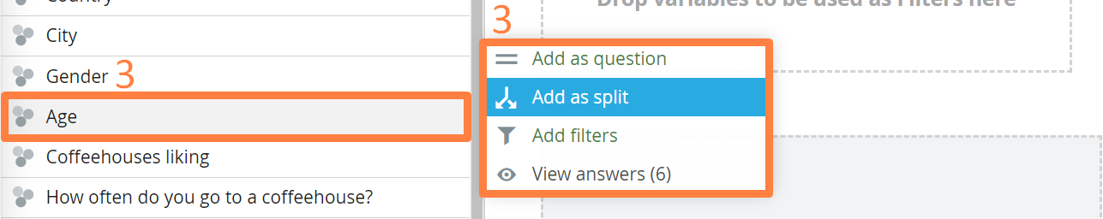
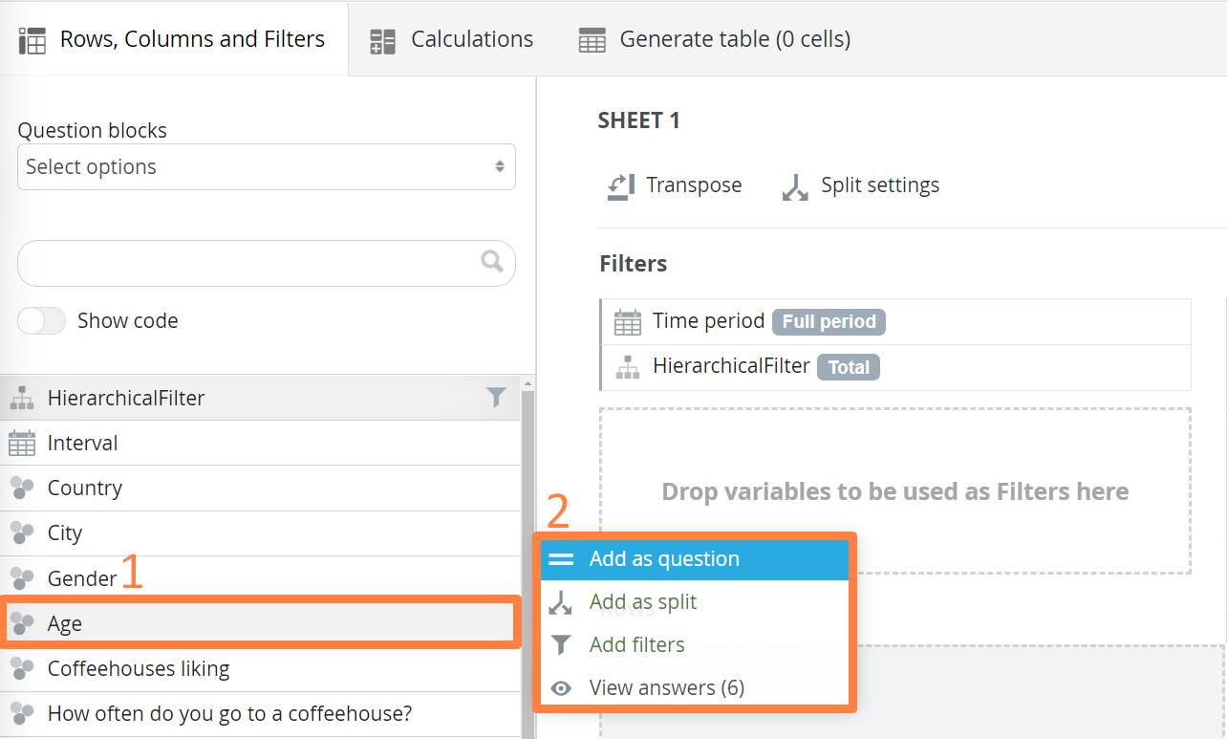

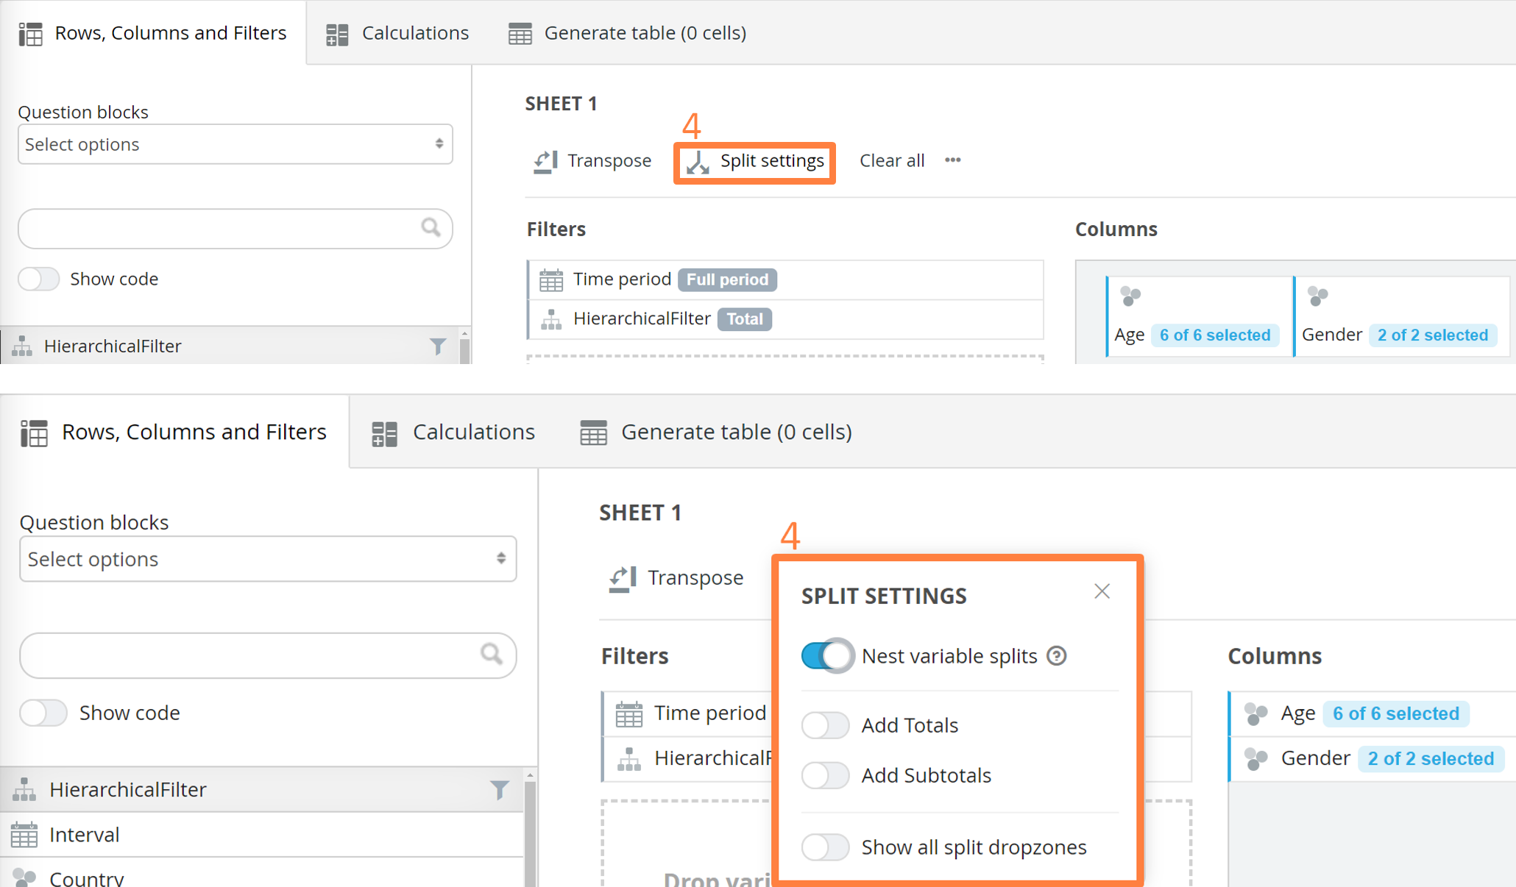

5. Press Generate button to run the crosstabulation for variables you selected.
6. Use the “Full screen” mode button when working with big tables.
7. The table can also be downloaded into Excel from this tab by clicking the “Export to Excel”.
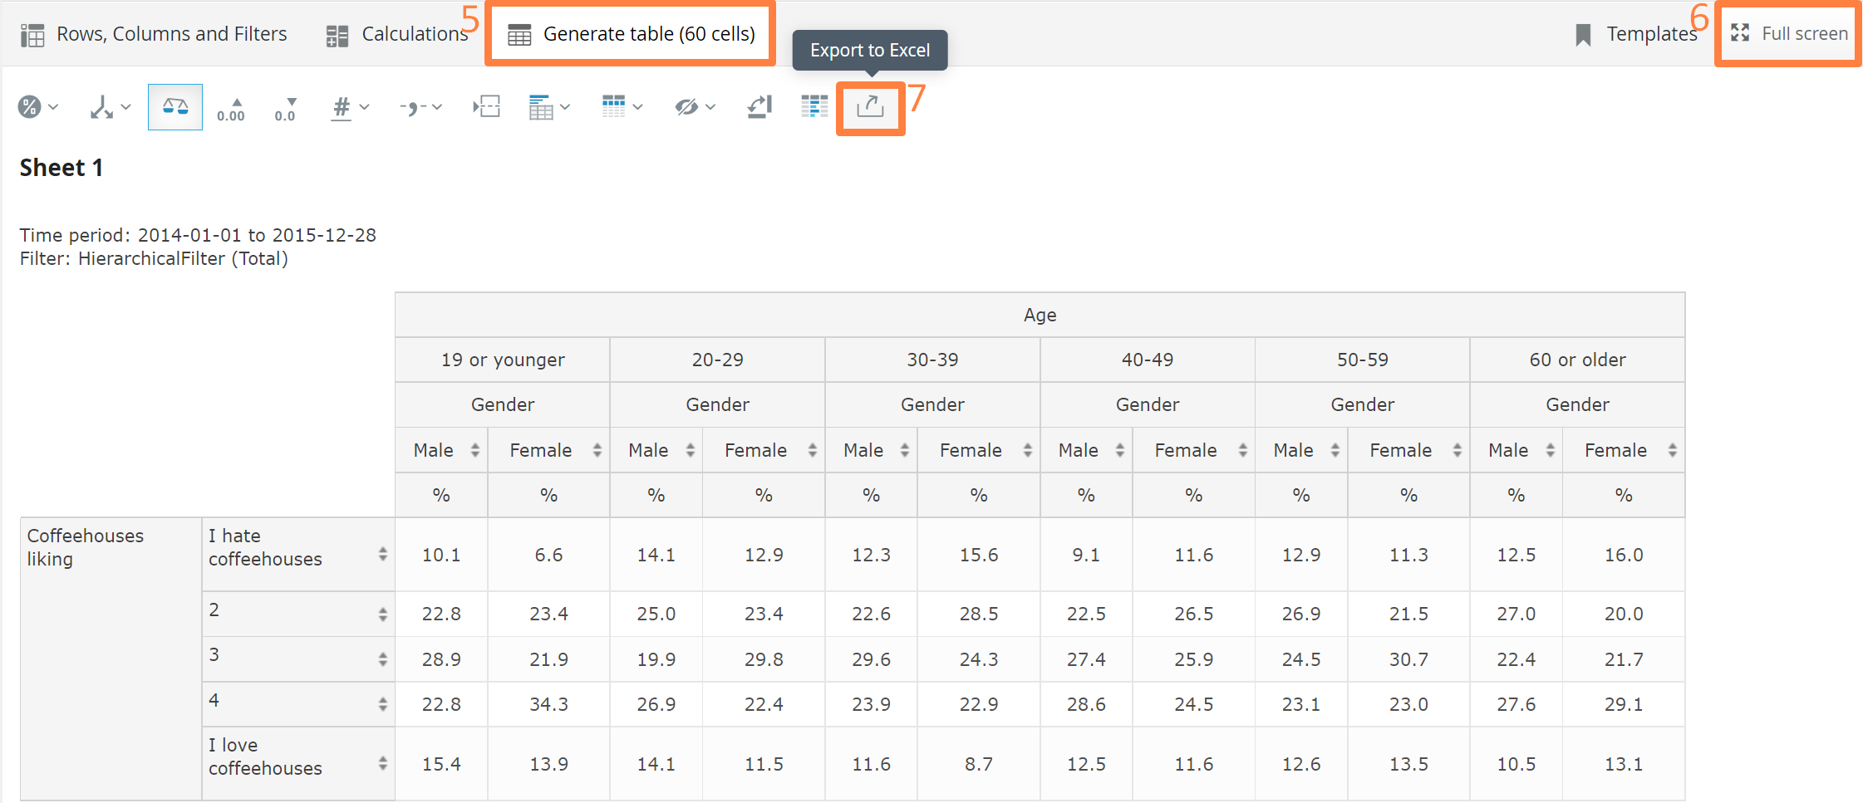

NOTE!
- You can ad multiple questions by holding Shift/CTRL and selecting questions at the same time.
- Additionaly, you can drag and drop questions form the list into rows, columns or filter area.
- The interval and hierarchical filters cannot be used as questions, so the option “Add as question” is not shown for those; they can only be used as splits.
- Only categorical questions, intervals (week, month, etc.) and the hierarchical filter can be used as splits. Numerical questions cannot be used as splits.
- If multiple splits are positioned in columns (or in rows), then you can define the “nesting” behavior. The selected splits will either be nested or shown side by side.

Additional Options

Position the Questions
The questions can be positioned in either rows or columns. This is done by drag & drop. The sort order inside the question group can also be changed. The whole question group can be dragged and dropped to the column area. It can either be placed between the nested splits or below/above the splits.

Step by step – Move, transpose, clear question selection

1. Select the questions you want to view the result for by clicking the “Add as question” button.
2. Hoover over added question until you see moving pointer to move the question box order.
3. Press Transpose if you want to swap places of questions and split.
4. To remove all split , question , period , brake or filters ONLY use the option menu “***”in the top left (which appears when clicking the “***” button) or “Clear all” to reset everything.
5. Click the “Clear” icon that appears in the question, splits or filters on hover over, to remove individual items.

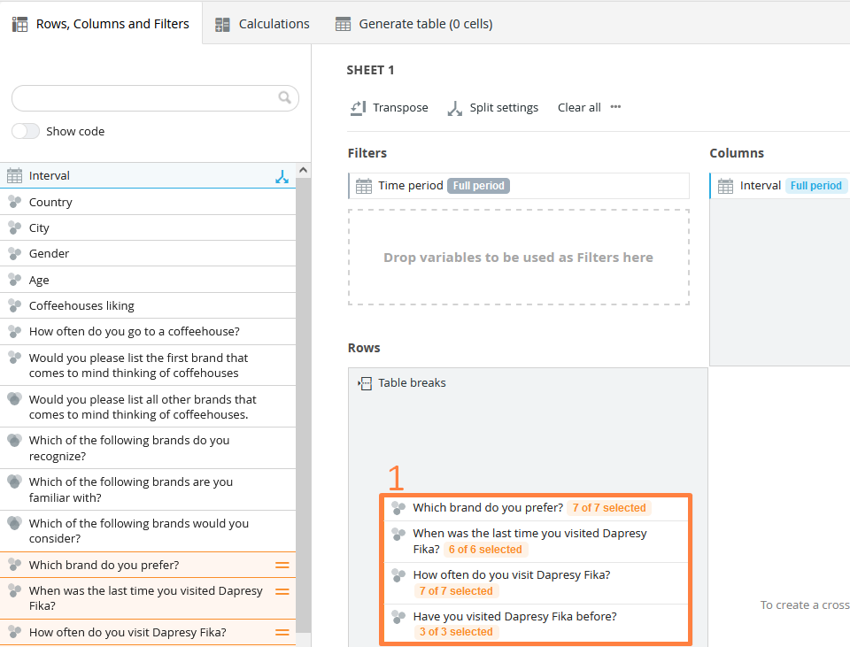



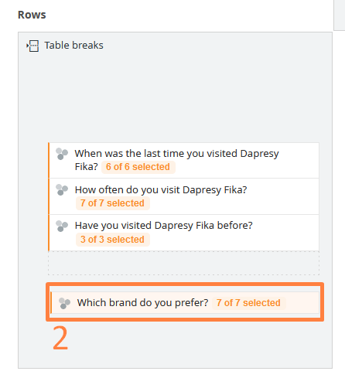
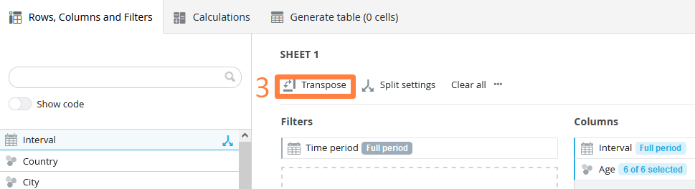

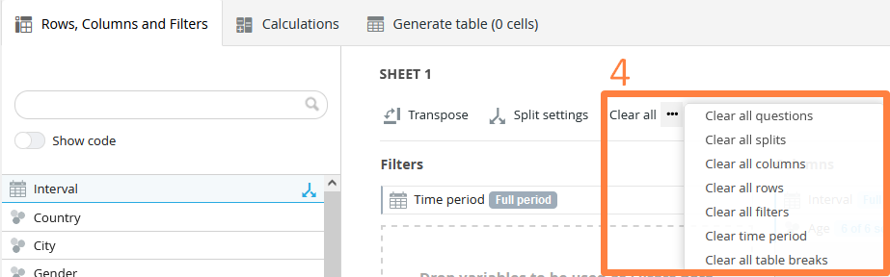

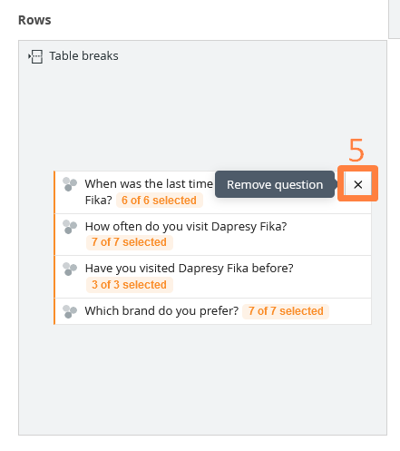

Select the Answers for the Questions and Splits
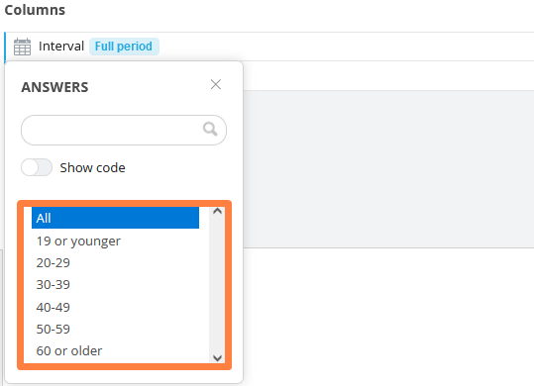
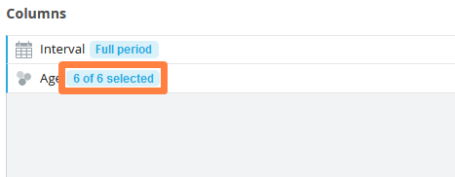
By default, all the answers are present in selected Question. You can limit the number of answers in the questions, splits or filters by selecting which answers you want to appear. To select the answer hover over the desired Question/Split and click the “Select Answer” icon. Then select the desired answers to be shown in the popup panel. Hold CTRL and click on individual answers. Additionally it can also be done through the selected questions, splits, filters by pressing the numerical information underneath.
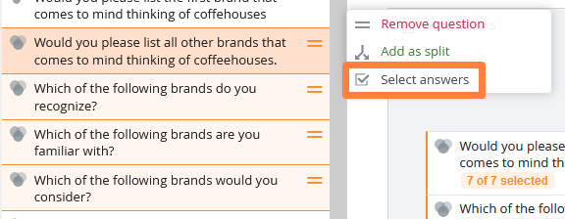

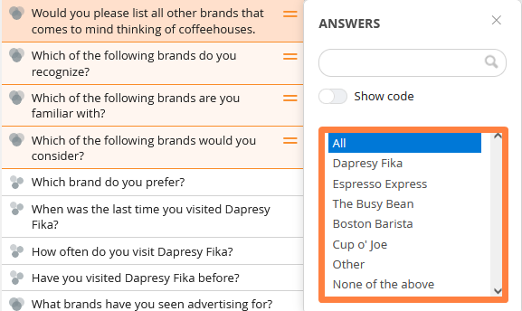

Due to the logic of answer blocks in Dapresy Pro, the questions (not the splits) which share the same answer blocks will always have the same answers selected. In the example below, all five questions are sharing 1 answer block. If you select to show only answers 4 and 5 in the question “Brand considerations – Dapresy telecom,” then the other 4 questions will show the same answer options. If some answers are selected in one of the questions, then the same answer selection will be applied to all five questions as they are sharing an answer block.

Add Totals and Subtotals Splits
You can add a Total and Subtotal Splits to your table, see details and the difference between the Total and a Subtotal below. The Total includes all respondents fulfilling the overall filters, and it is not being nested with any other Split. The Total appears in columns and/or rows if you have Splits in columns and/or rows. The image below shows an example of a Total in columns. By default, it appears in the last column, but it can be changed to the first column if you would like.
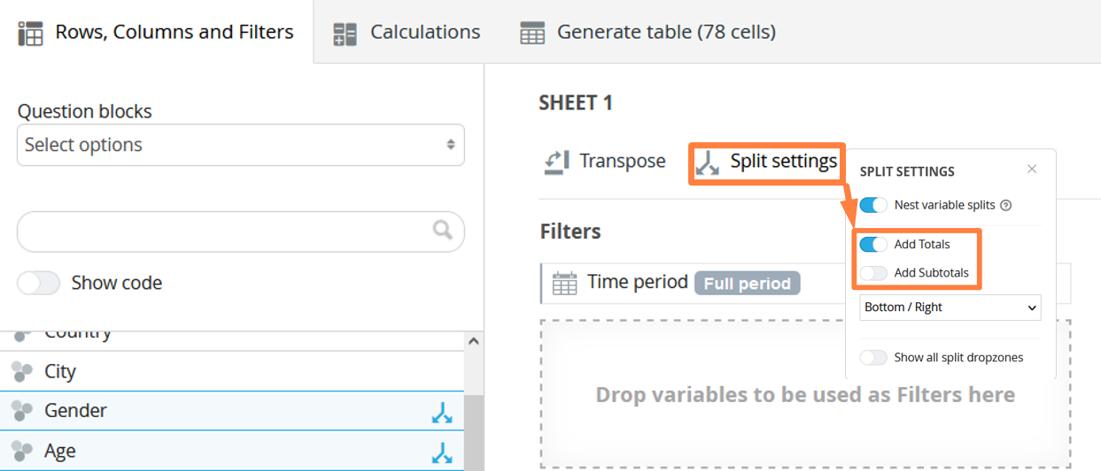

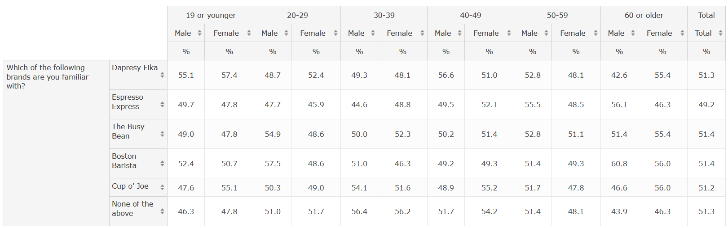
The image below shows a table with Splits in both columns and rows, so you can see the Total in the columns and in the rows.
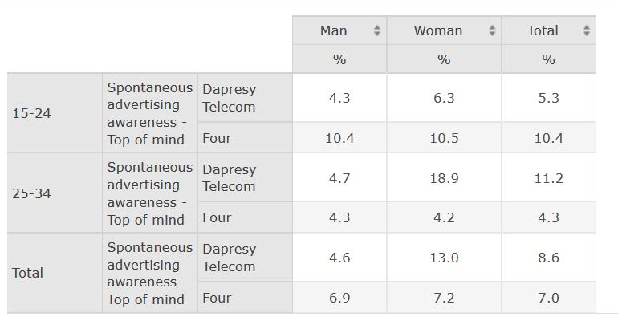
The Subtotal is added as a column (or row) per selected Split. For example, if the two variables Gender and Age groups are shown as splits, then you will get one Subtotal for Age groups and another one for Gender. Each Subtotal is based on the respondents included in the shown options of the Split. So if the Age group variable has five options but only two are shown in the table, then the Subtotal for the Age

group variable will consist of all the respondents belonging to those two options. The image below shows the same table as the one above, but the Subtotals are shown instead of the Total. As you can see, one Subtotal is generated for Age groups and another one for Gender.
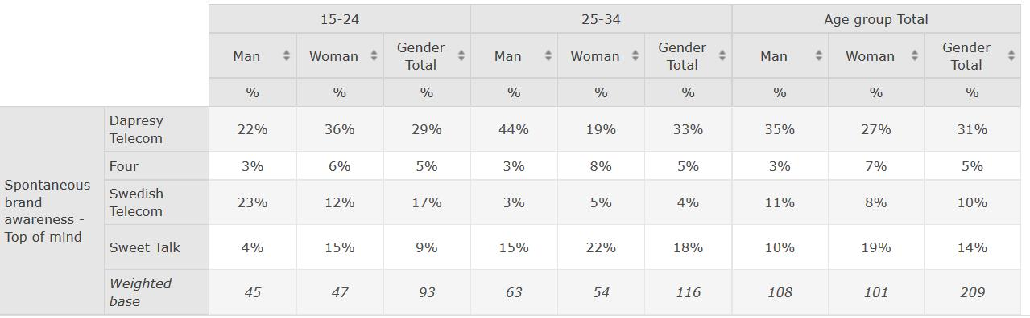

The Total and the Subtotal can be used simultaneously, as shown in the example below. The table below is the same table as the one shown above, but both the Total and the Subtotals are shown.
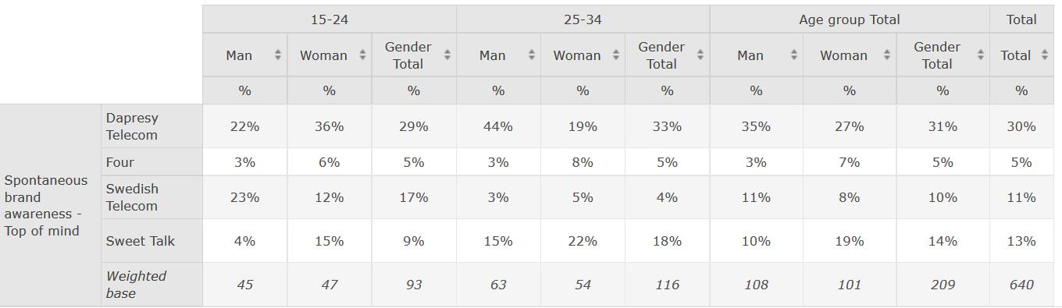

How to add filter to Cross table

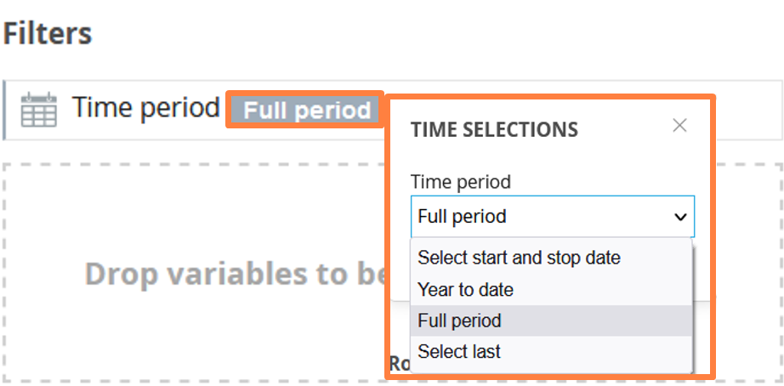
Cross table report allows you to quickly add filters and apply hierarchical filter to your variable selection. After adding variables to Rows and Columns you can Generate the table immediately or apply filters to your data limiting the time or variables shown. In the Time Selection panel, you can limit the data by selecting a specific period. By default, it is set to the full period. The image below shows the time selection panel.

In the drop-down list, you can select from the following:
- Select start and stop date: Use this option to select a specific date range in calendar controls
- Year to date: This shows all data from the 1st of January (this year) until today’s date
- Full period: Includes all respondents

Categorical Filters and Hierarchical Filters
All categorical variables and the hierarchical filters can be used as filters. To apply a filter, simply select the variable by clicking the “Add as filters” button in the panel that appears when you hover over a variable in the list. You can either select one at a time or hold Shift/CTRL to select multiple splits at a time.

Step by step-adding filters to Cross table
1. Go to Cross-table variable list ribbon menu. Find filter menu under Time options.
2. Select variable to use it as a filter by Add filters options.
3. Select answer options for the filter variable you want to use.
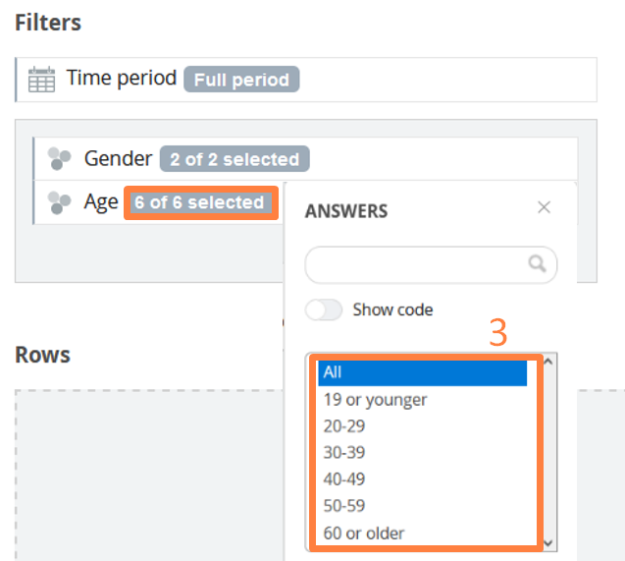
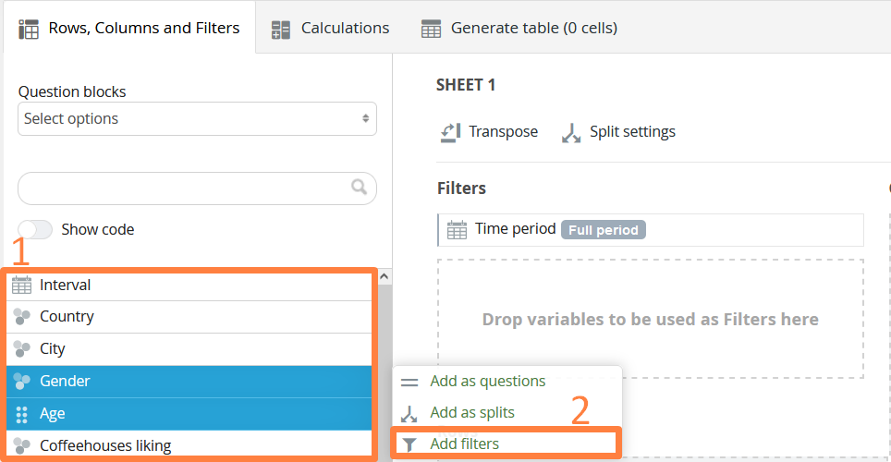


Hierarchical filter in Cross table
If the project contains a hierarchical filter, then it’s filtering the result by default. If the hierarchical filter is removed as a filter, then it will automatically appear as a split in the Row and Column tab. If it’s removed as a split in the Row and Column tab, then it will automatically appear as a filter. The same variable cannot be used as both Question/Split and as a Filter at the same time. If a variable is disabled in the Filter tab, then it is used in the Row and Column tab and vice versa.
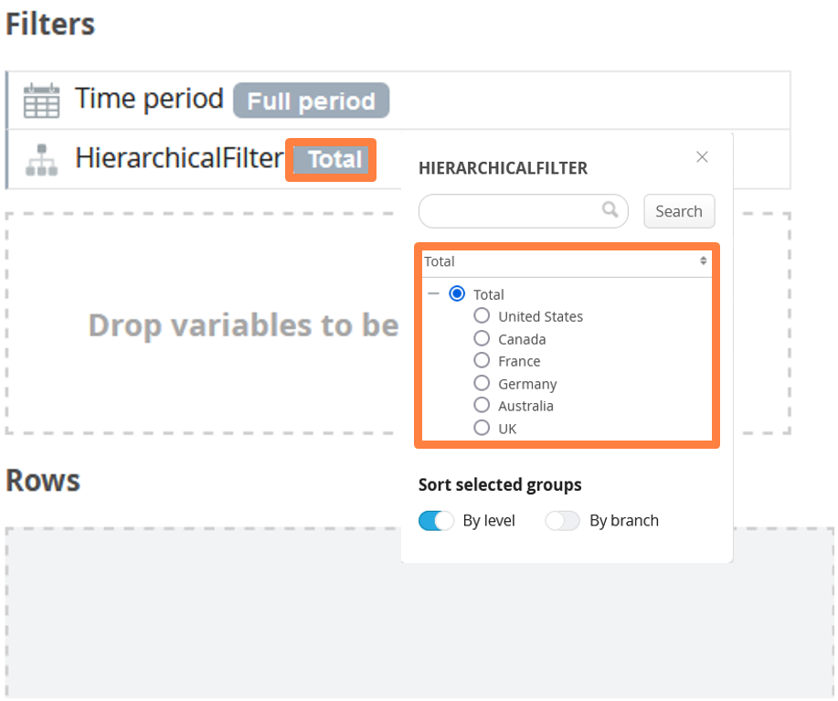

Generate cross table
Before using Generate button please note an indicator next to Generate button that shows the number of cells to be calculated. The purpose of the indicator is to provide an overview of how big the table will be, as a bigger table means longer calculation time. By indicating the number of cells to be calculated, the table setup can be changed before the table is generated.
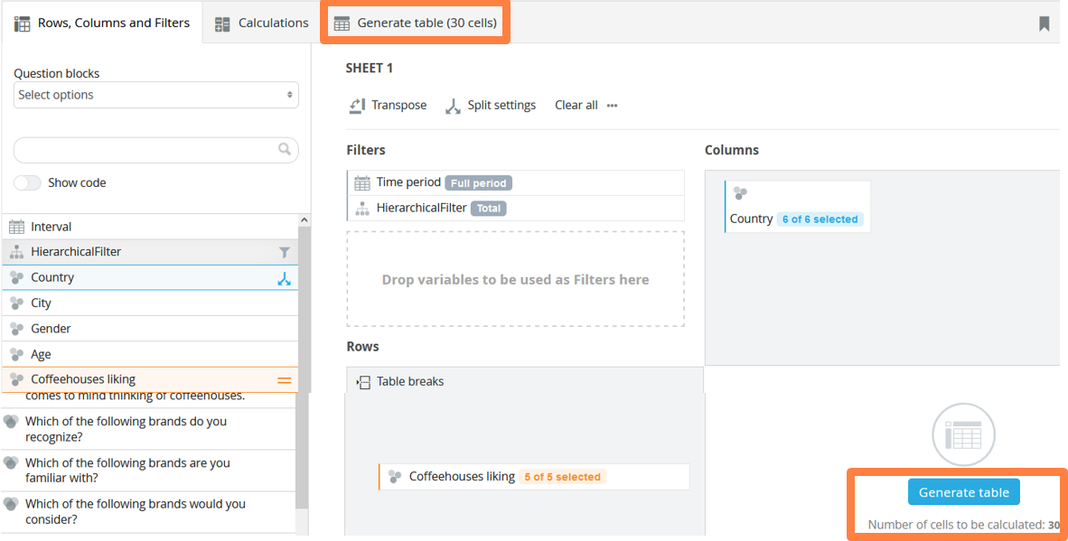

By clicking the Generate tab, the table will be generated. The table can also be downloaded into Excel from this tab by clicking the “Export to Excel” button in the top right corner. The thousand and decimal separator used online will be used in the Excel exports. If the table shows a period as the decimal separator but you want to use a comma, you can change this in the Settings tab in the Table formatting panel.

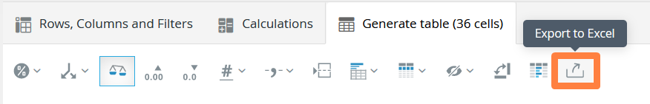
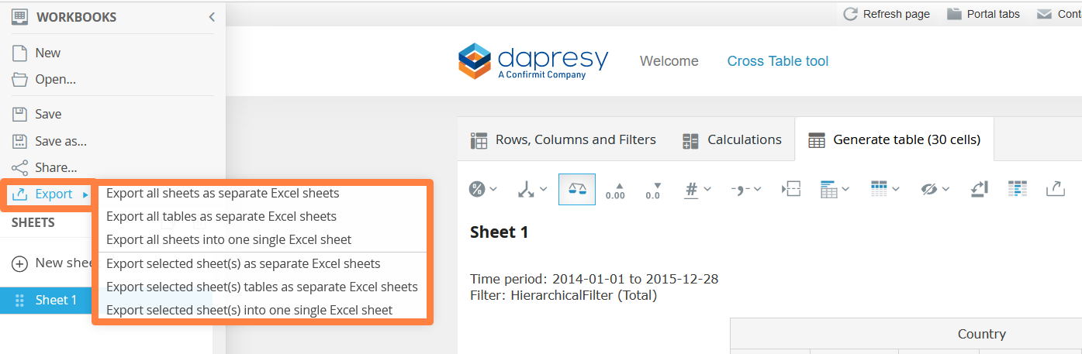

In the Generate tab, you can sort the table by clicking the desired column (or row) header of the split that the sorting will be based on. If the questions are positioned in rows, then you can sort by clicking the column headers. If the questions are positioned in columns, then you can sort by clicking the row headers.
Since a table can show the results of multiple calculation types, like the percentage value, the mean value, and the correlation analyses value, then you need to define which calculation type the sorting will be based on. You can make this selection in the Generate tab in the top left corner (the list only appears when multiple calculation types have been applied to the table). The image below shows the list you can choose from when selecting which calculation type the sort order will be based on.
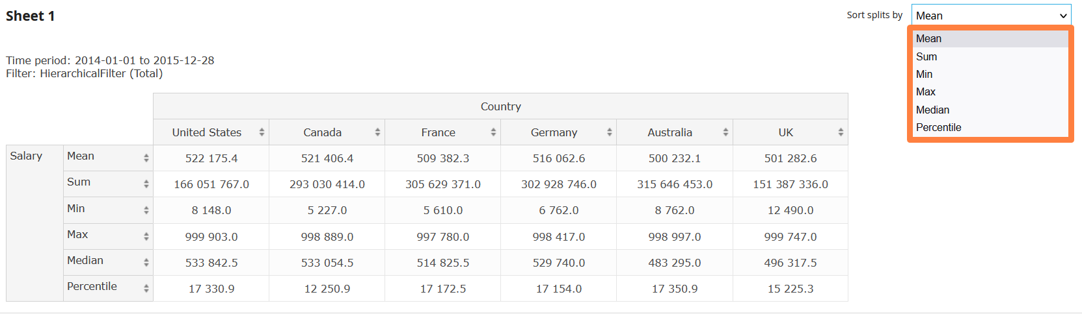

NOTE!
- The sorting function is disabled if both Numeric and Categorical variables are used as questions in the table. This is due to the fact that different variables use different calculation types, so it’s impossible to create one logical sort order.
- If you have a table with categorical variables and you sort the table by count or percentage share, then the sorting is made within each question if the questions show more than one answer alternative. If all the questions only show one answer alternative, then the sorting is made across all questions.
- When a table that has more than 50 000 cells is generated, you will see a message informing you that time is required to generate the table: “Generating table with more than 50 000 cells could take a significant amount of time.”

Calculations in Cross table
In the calculations tab, you can select the calculations to apply to the selected questions. Only relevant calculation types are shown here. This means that the Categorical questions have one set of available calculation types, and Numerical questions have another set of calculation types.

Calculation types
The categorical calculation types ‘Percentage share’ and ‘Count’ are only shown if at least one categorical question has been selected
The categorical calculation type ‘Mean’ is only shown if at least one categorical scale question has been selected
The Significance testing options are only shown if at least one categorical question has been selected
Numeric calculation types are only shown if at least one Numeric question has been selected.

The Correlation analysis option is only shown if at least one Numeric or one Single-choice categorical question has been selected. If only a Multiple-choice categorical question or an Index question has been selected, then the Correlation analysis option will not be shown

Standard Calculations panel
In the standard calculations panel, you will find the following calculation types:
Categorical questions: Percentage share, Mean, and Count
Numeric questions: Sum, Mean, Median, Min, Max, and Percentile
To use a calculation, simply select which ones you would like to use. As shown in the image below, you can also adjust the number of decimals per calculation type. If you would like to add any suffix/prefix, like a “%” sign, to a table, then you can define that here. The image below shows what the standard calculations panel looks like when categorical scale questions have been selected in the Rows and Columns tab.

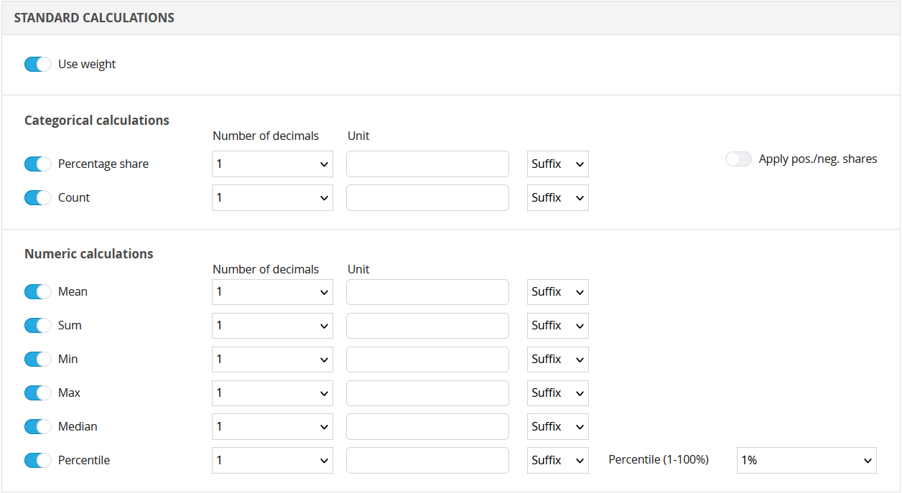
The image shows what the calculations panel looks like when Numeric questions have been selected in the Rows and Columns tab. At the top of the standard calculations panel, the weight can be turned on and off. If the project contains multiple weight variables, then the weight variable to use is in the calculation is also selected in this area. The image below shows the setting used to turn the weight on and off.

Correlation Analysis
The correlation analyses use the Person’s formula. The correlation analyses can be applied to the tables as soon as any Numeric or Single-choice categorical question has been selected in the Rows and Columns tab.

Step by step – correlation analysis

- Select the variables for Rows and Columns (any Numeric or Single choice categorical).
- Go to Calculation Tab and in Correlation analysis and enable the calculation.
- Select if the R or the R2 value will be calculated and question the test will be performed against.
- Adjust the number of decimals, Unit and Suffix you want to see in the table with results.
- Press Generate to perform the analysis as per the settings selected.
- The information above the table shows which question the correlation analysis is made against.
- The correlation result will appear as a last row in the table.

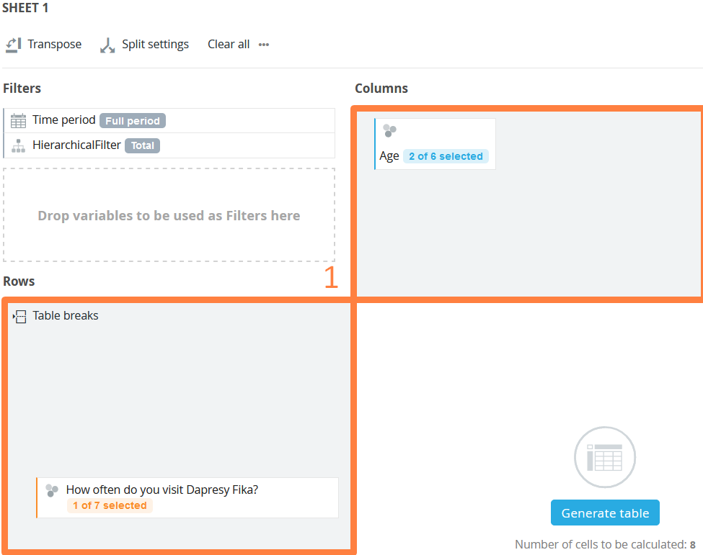


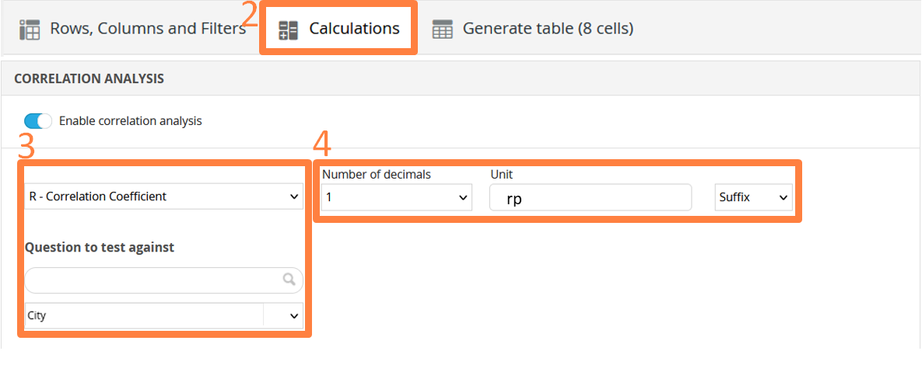

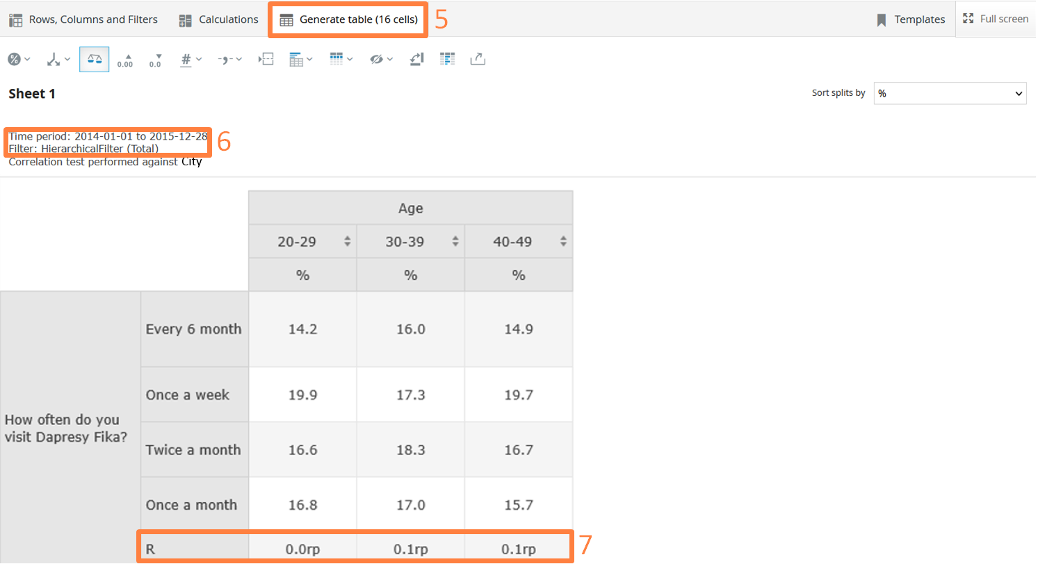

Significance Testing
In the significance testing panel, you can turn on significance testing. The settings are similar to creating a chart or a table in the Storyteller. This means that the following must be defined:

Step by step-significance testing

1. Select the variables for Rows and Columns.
2. Go to Calculation Tab and in Significance testing.
3. Enable significance testing
4. Select the significance level from the dropdown menu (1%, 5% or 10%)
5. Select the base size option to use in the calculation.
6. Select Results to show.
7. Select if the test will be made across columns or rows.
8. Select Comparison columns.
9. Select If any Base limit or Respondent Count limit must be fulfilled to perform the test.
10. Select to show the result in separate cells or value cells.

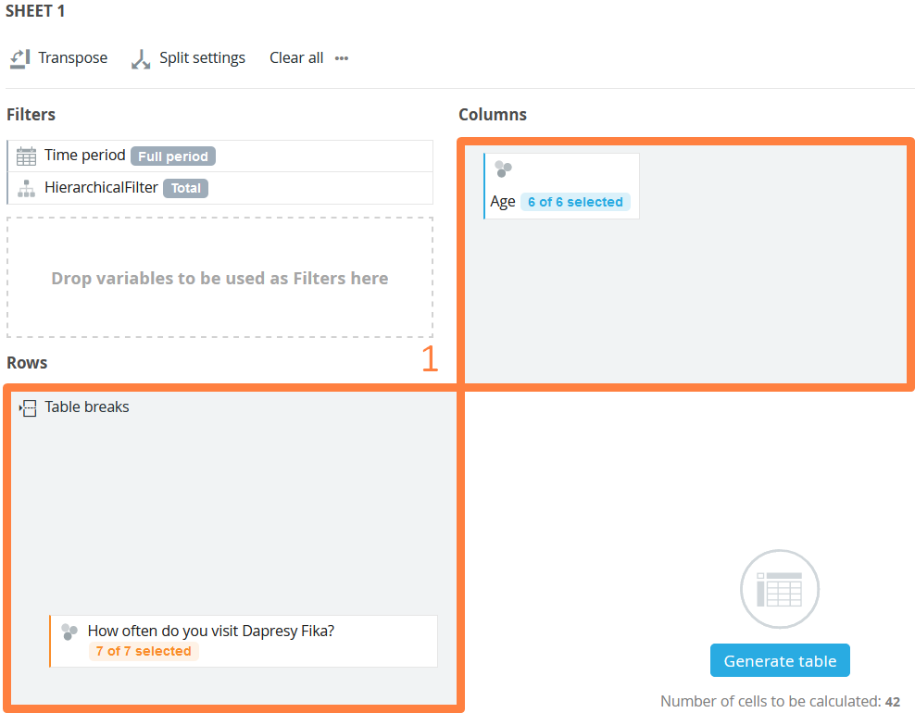

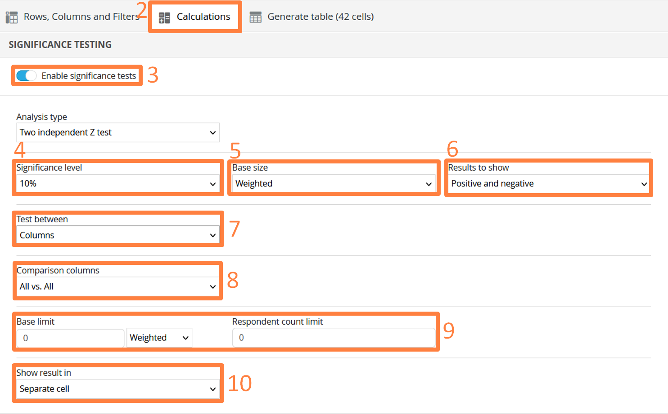

NOTE!
The base size option to use in the calculation is only shown if the result is weighted. If the result is unweighted, then an unweighted base is always used in the calculations.

Additional Options

Visualize Significance Test with Colored Values
The significance test results are shown with symbols such as +/- or with colored cell backgrounds. There is also an option to allow visualization of the results with colored values. When all columns are tested against all columns (or all rows against all rows) the visualization of the result is always made by “symbols” (like a+, b-, c-, etc.) since each value/cell can be both positive and negative. When only testing against one column (or row) the result can be shown with symbols or as colored cell backgrounds since each cell can only be positive or negative. This option is not shown when all columns are tested against all columns or when all rows are tested against each other.

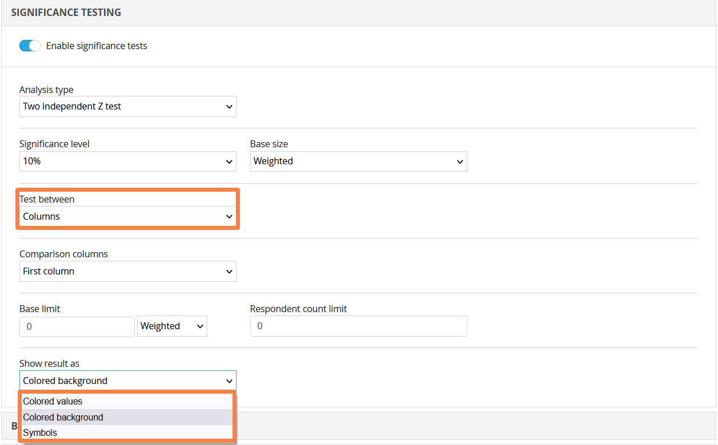

To use colored background to visualize the significance test, simply select the “Colored background” option in the in the “Show result as” list.
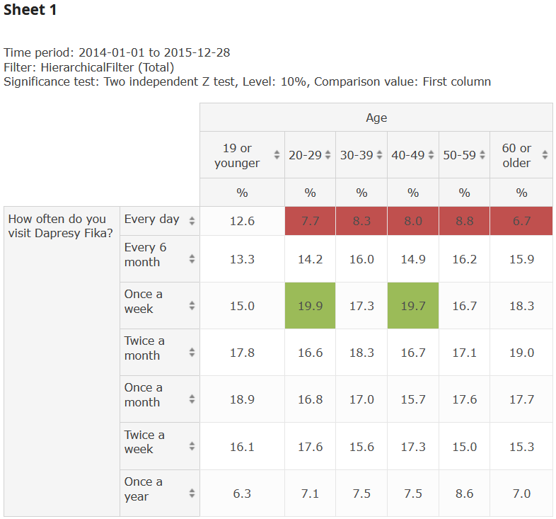

The significance test result can be visualized with colored values when a value is tested against another value. This option is not available when all values in the table are tested against each other.
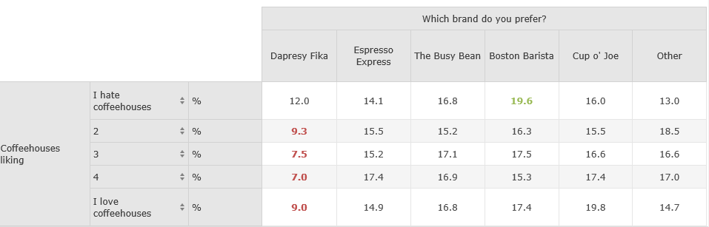

The value colors for positive and negative results are defined in the Project settings page, as shown in the image below.
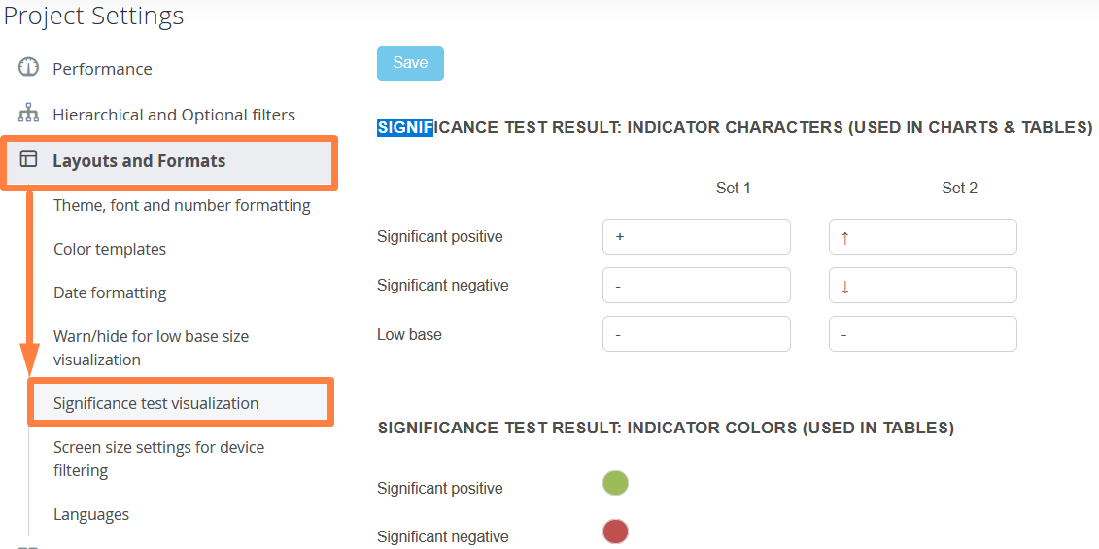

Benchmarks
In the Benchmark panel, you can turn on the benchmarking calculations to benchmark one result against other results. As with the other calculations select the variables for Rows and Columns first.

Step by step – using benchmarks

1. Go to Calculation Tab
2. Enable benchmark calculation.
3. Select calculation type (Units, Percentage share or Index/Conversion rate).
4. Select if the original result will be hidden or shown together with the benchmark result.
5. Select if the benchmark calculation shall be made across columns or rows.
6. Select Comparison columns.
7. Select if the comparison column will be hidden or not.
8. Select to show the result in separate cells or value cells.

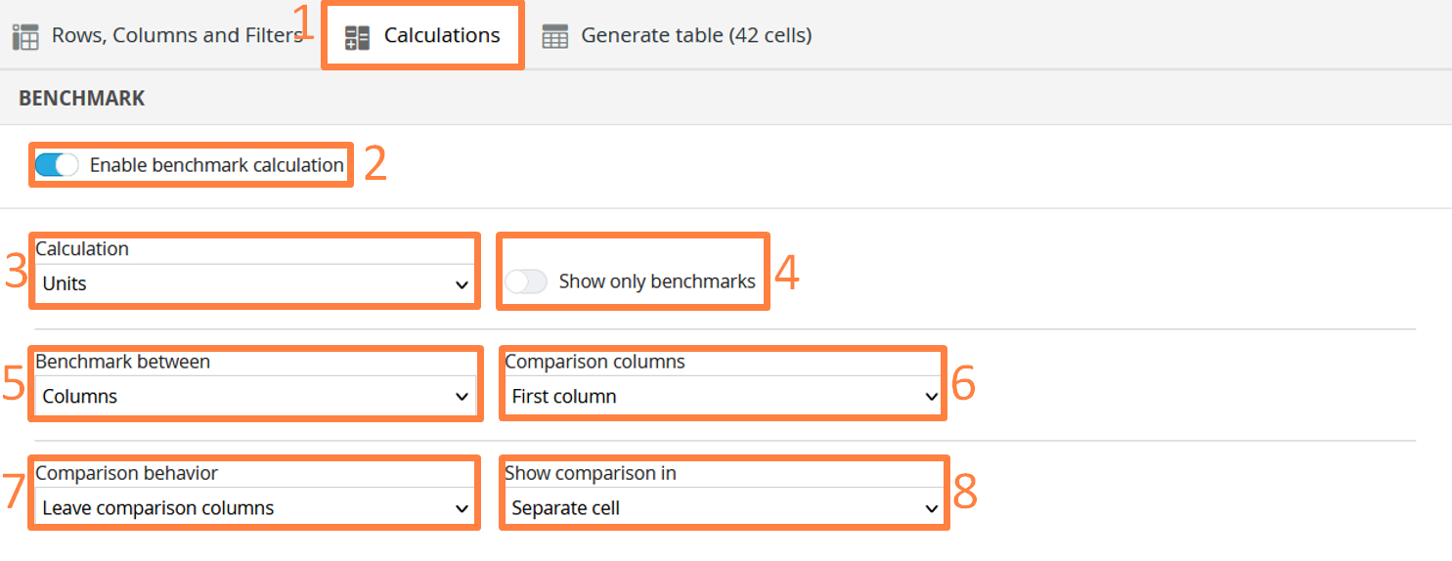
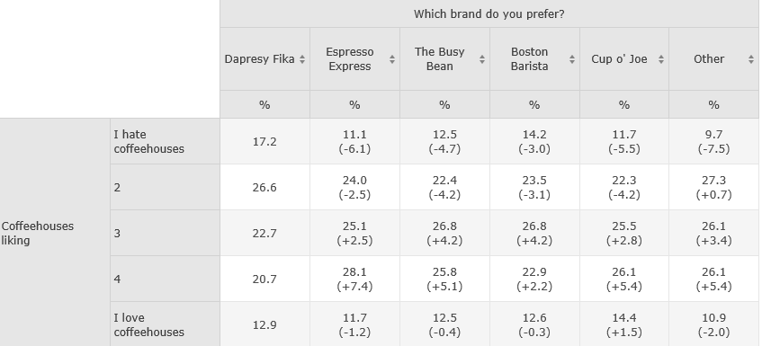

Additional Options
Three types of benchmark calculations are available:
Units
Percentage share
Index/Conversion rate

Below are descriptions of the formulas. In this example, result A is 80% and result B is 50%. The B result is benchmarked against the A result:
Units: 50-80=-30 (B-A)
Percentage share: (50-80)/80*100=37,5% (B-A)/A*100)
Index/Conversion rate=50/80*100=62,5% (B/A*100)

All three calculation types can be applied to all calculation types such as %, Mean values, and Count & Correlation analyses result. Below is an example of the Index/Conversion rate calculation.

Settings in Cross table
In the Settings tab, you will find the base size limits and some formatting settings. In the base size limits panel, you can select if the base size should be shown or not. If the result is weighted, then both the weighted and the unweighted base size can be shown, or just one of them. If the result is unweighted, then only the unweighted base size can be shown. These settings are made in the “Display base” area. To show the base size in the table, simply select the Weighted base and/or the Unweighted base options in the Display base area.

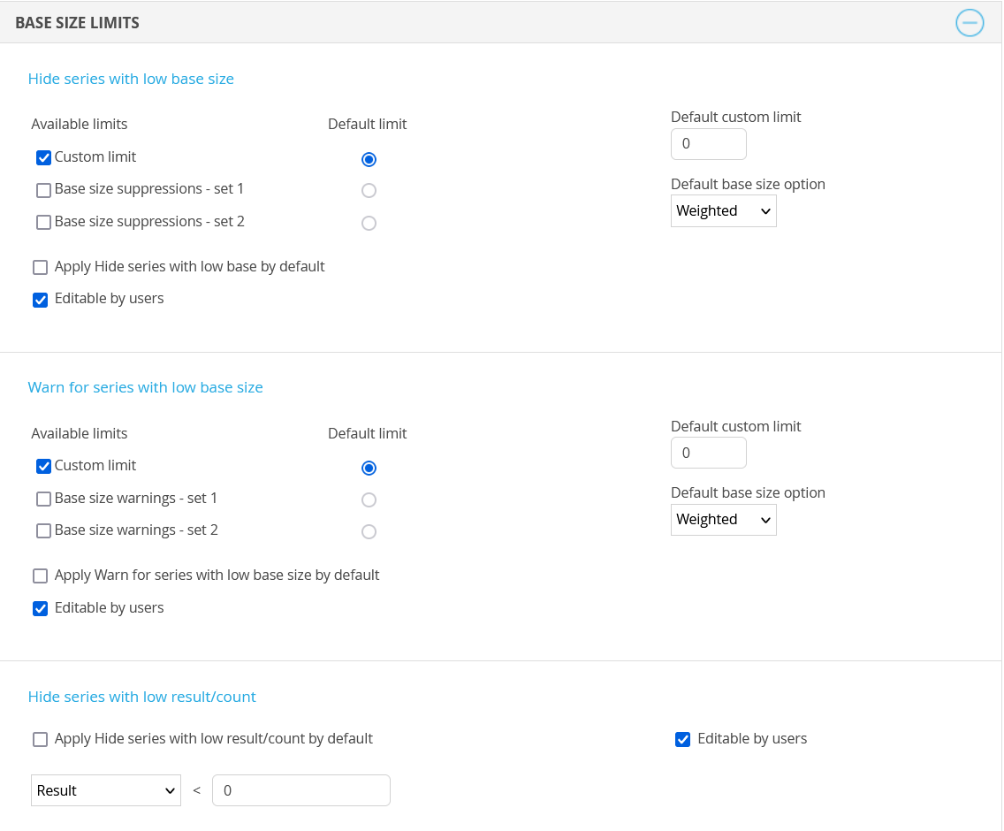

In the area “Warn for series with low base” and “Hide series with low result/count” you will see settings used to hide results due to a low base size/result and the function for warning due to a low base size. These settings can be turned on/off, and the limit can also be entered in the input fields. The default limit and the default setting can be defined in the setup phase. If the result becomes hidden or if there is a warning due to a low base size, then an information message will appear above the result table in the Generate tab (see example image below). The displayed text (“*Low base size” in the image below) comes from the project settings page, so it can be adjusted to suit the needs of the project (see the second image below).The image below is an example of a table with a low base size, as explained by the displayed text “*Low base.” This text comes from the project settings page.

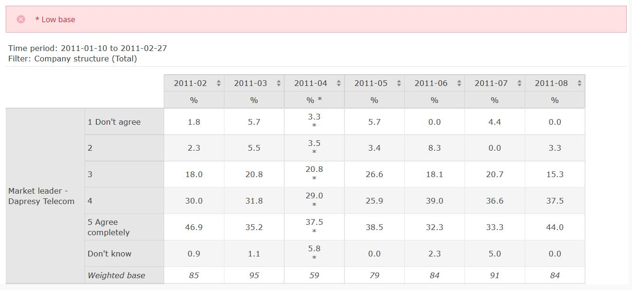
The image below shows the project settings page. The following texts will appear if the base size is low or if a result is hidden due to a low base size.

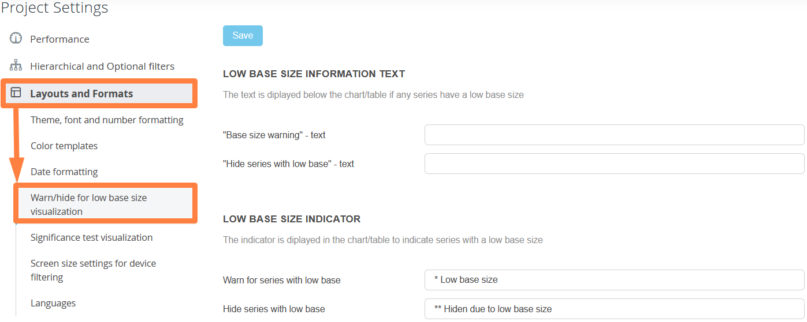

Additional Options

In the “Hide empty series” area, you can hide rows and columns without data/results. The following three options are available. They can be used simultaneously if needed.
Hide date gaps: Use this option to remove intervals (weeks, months, etc.) without data. See example 1 below.
Hide empty series: Use this option to remove splits without data, and answer options with a count = 0. See example 2 below.
Hide splits with No Data: Use this option to remove a split option which without data. See example 3 below.
Example 1: By activating “Hide date gaps,” all the highlighted columns will be hidden.

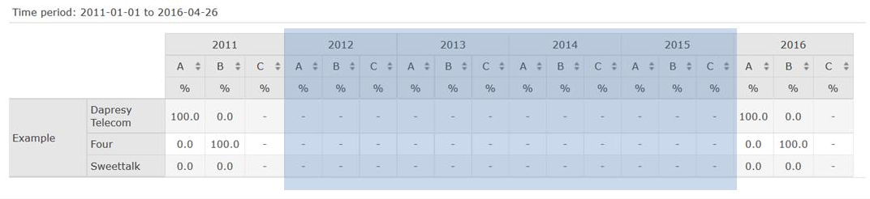
Example 2: By activating “Hide empty series,” all the highlighted rows and columns will be hidden.
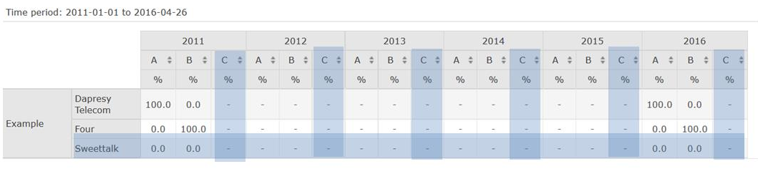

Example 3: By activating “Hide splits with No Data,” all the highlighted columns will be hidden.
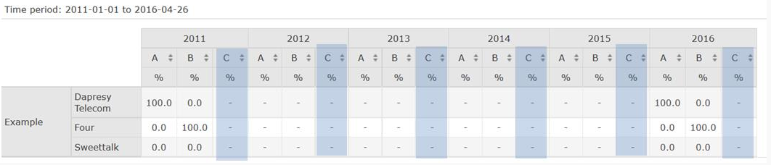

My favorites in Cross table
In the Favorites tab, you can save all your favorite tables after selecting variables and calculations. This will help save time in ongoing projects that are continuously loaded with new data. When new data is available, you can easily load your favorite tables without having to edit all the settings again

How to use Favorites in Cross table

Step by step - creating favorites

- Under settings untoggled “Allow saving Workbooks” and toggle “Allow saving Favourites”
- Select the questions you want to view the result for by clicking the “Add as question”.
- Go to the Favorites tab and enter the desired name and description (the description is optional).
- Choose the name for your favourite and add some comment (optional)
- If you would like to be able to share the table, then tick the “Share with all users” option or ”Share with selected users” for finer control.
- Press Save.
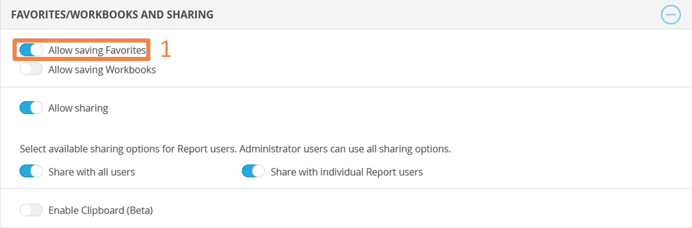

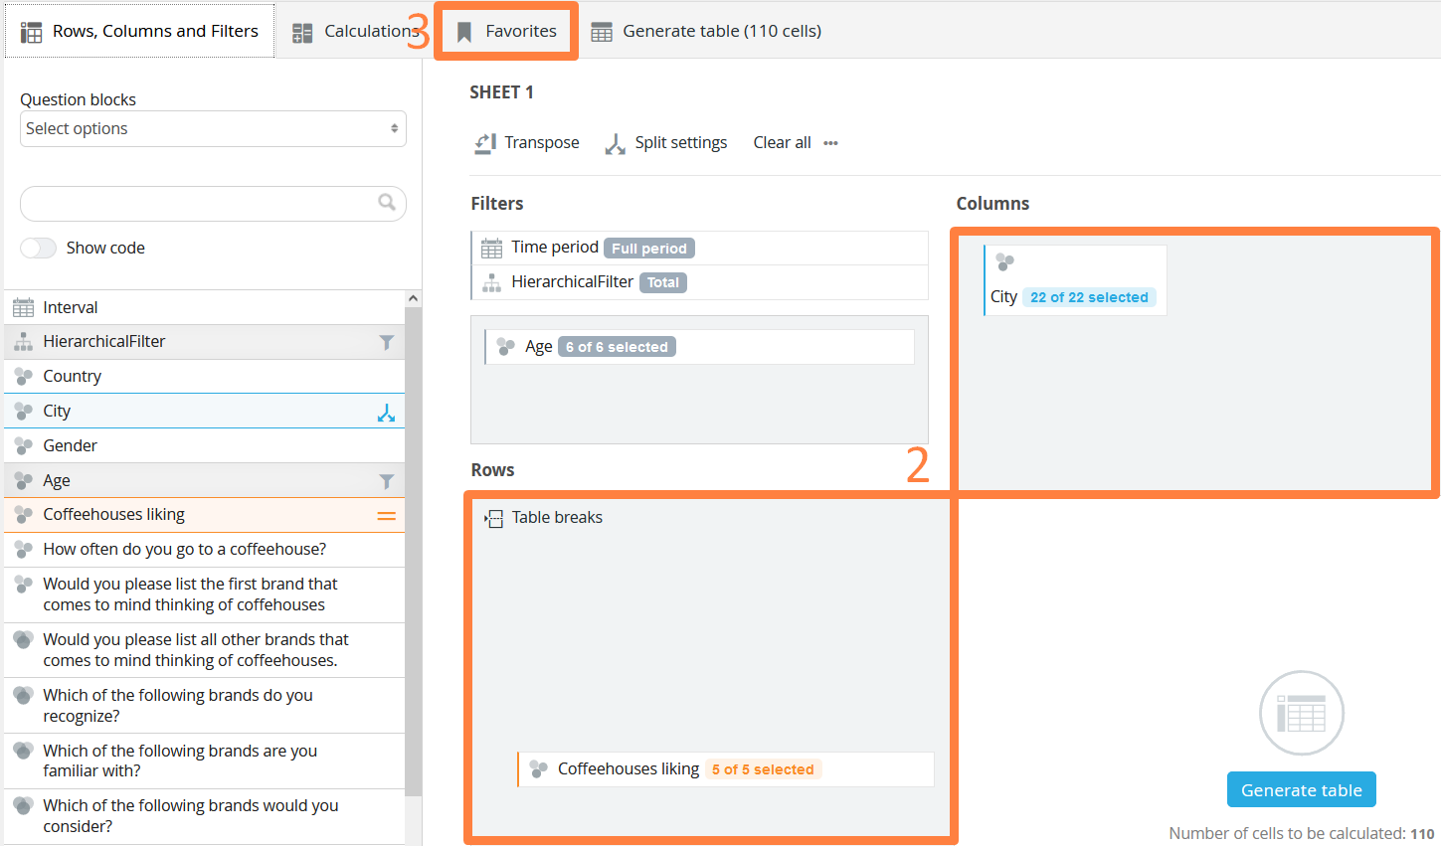

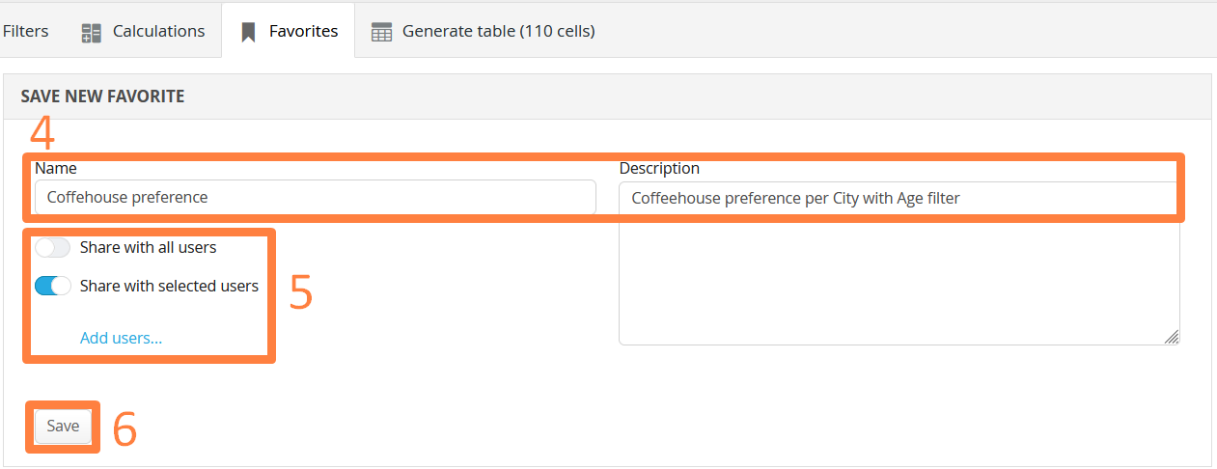

NOTE!
- If the project has hierarchical filters, then these settings are not saved as a part of the favorite.
- If you want to update an existing favorite, you can save a new favorite with the same name as the existing favorite – this will replace the old favorite with the new one.

Shared favorites
Your favorites are personal, but you can select if you would like to share them with other users or not. A shared favorite can only be viewed by other users, but it cannot be edited or deleted. In the Favorites tab, each user can save their favorite tables for future use. A table can be shared or private. All shared favorites, created by other users, can also be found in this tab.

Step by step

1. To load a personal favorite click ‘Load’ on the favorite. This will load all settings.
2. To delete a personal favorite click ‘Delete’ on the favorite you wish to delete.
3. To load a shared favorite click ‘Load’ on the favorite. This will load all settings.

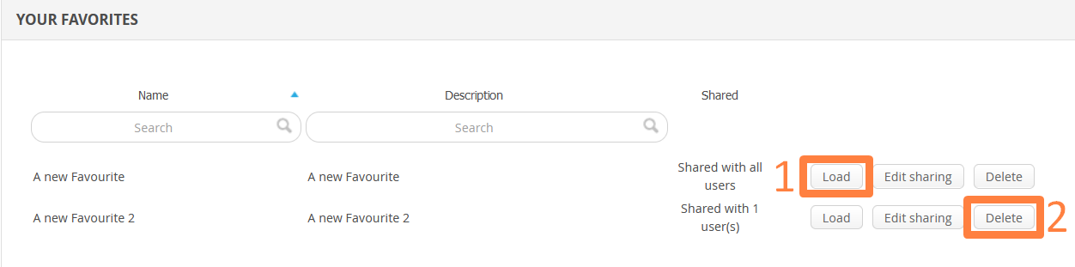
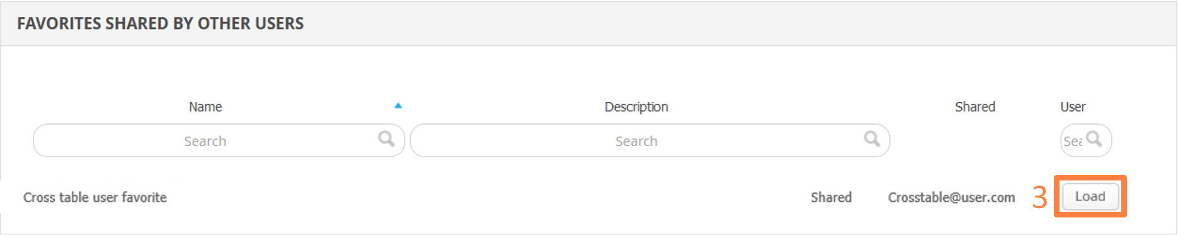

Workbooks in Cross table

A “Workbooks and sheets” concept has been introduced in the Cross Table tool which is much like the existing decks and slides in the StoryCreator. This allows you to create a set of tables (sheets) and save these as a workbook.
The workbook can be exported to Excel or shared with other users. The new workbook functionality improves efficiency when bulk creating tables, as sheets can be duplicated, reordered, etc. All sheets in a workbook can be exported to an Excel file.

Important to note is the fact that the Workbook logic cannot be used in combination with the Favorites feature, so you must select whether you will use Workbooks or Favorites in your Cross Table tool report.

How to use Workbooks in Cross table

Step by step - creating workbooks

- Under settings untoggled “Allow saving Favourites” and toggle “Allow saving Workbooks”
- Select the questions you want to view the result for by drag and droping questions/splits.
- Go to the workbook panel and save the workbook using desired name and description (description is optional).
- Choose the name for your workbook and add some comment (optional)
- If you would like to be able to share the table, then tick the “Share with all users” option or ”Share with selected users” for finer control.
- Press Share.

Enabeling Workbook Panel

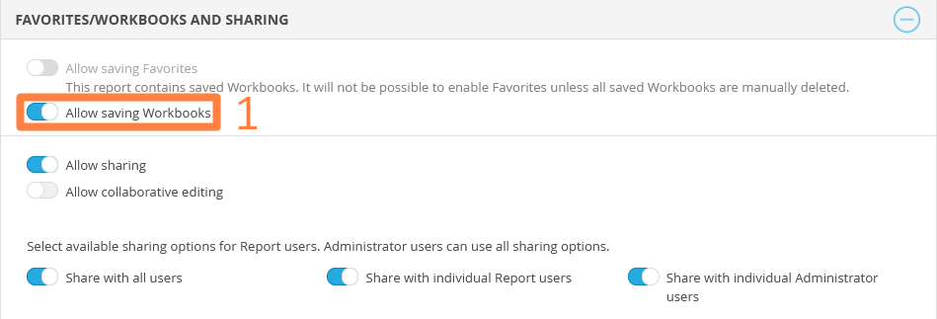
The workbook logic is not enabled by default in the Cross Table tool, you enable the Workbook logic in same panel as you previously enabled the Favorite function as shown below.
If the Cross Table tool contains saved Favorites and Workbook logic is applied instead each saved Favorite will be converted into a Workbook with a single sheet.
Additionally, when the new Workbook logic is applied the “Setup” option is moved from the top right corner of the Cross Table tool to the bottom of the Workbook and sheet panel, see below.

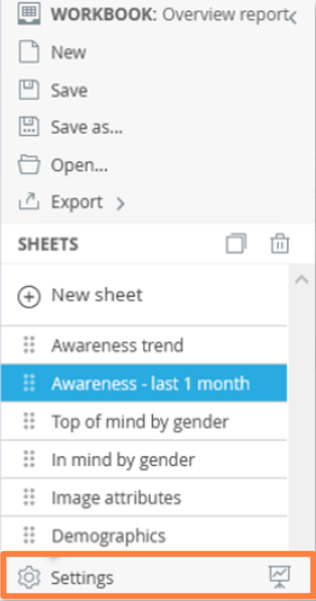

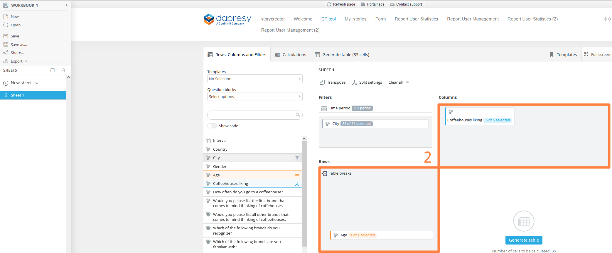
Note: It is not possible to go from using Workbooks to using Favorites as Workbooks cannot be converted to Favorites. If you have a need to use Favorites instead of Workbooks you must first manually delete all saved Workbooks.

Workbook Panel
In the Workbooks panel you can save, load, share and export the workbooks you build.
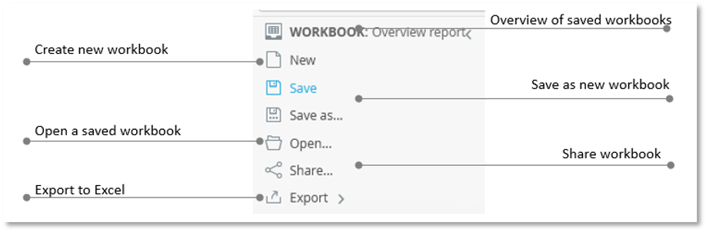

Save Workbook
To save your workbook a use the “Save as” button in the Workbook panel. In the popup panel you enter the name and a description of the workbook, the description is optional. You can also select if the workbook should be loaded by default when you next time enter the same Cross Table tool report.

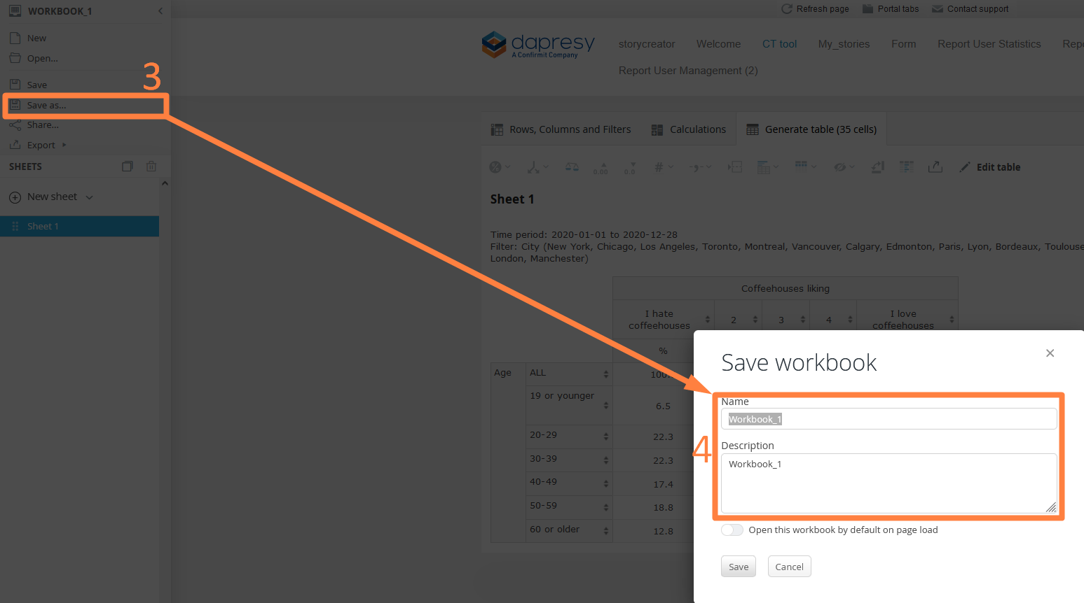
Here we see the Save Workbook panel.

Tip: If you are working in an already saved workbook, or have opened an existing one, and want to save the latest changes use the “Save” button instead of “Save as”, it saves the workbook in the same name automatically.

Note: if the Cross Table tool contains a hierarchical filter the selected nodes are saved on each sheet which is a difference compared to Favorites. When saving a Favorite the selected nodes are not saved.

Open a saved Workbooks
To open an existing workbook click the Open option in the Workbook panel. In the popup panel you will see your own workbooks, to load any of these reports click the name of the one to be opened.
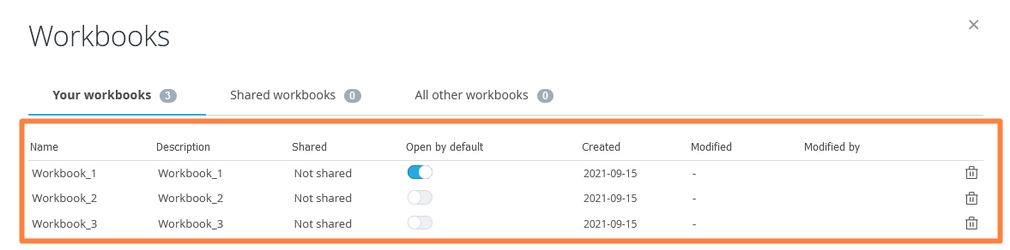
Here we see the Open panel, just click the deck to be loaded.

Delete a Workbook

A workbook can be deleted from the workbook overview panel. You reach this panel by clicking the first option named Workbooks in the Workbooks panel. In the appearing popup panel the delete option is shown to the most right.

Here we see how to delete a workbook.
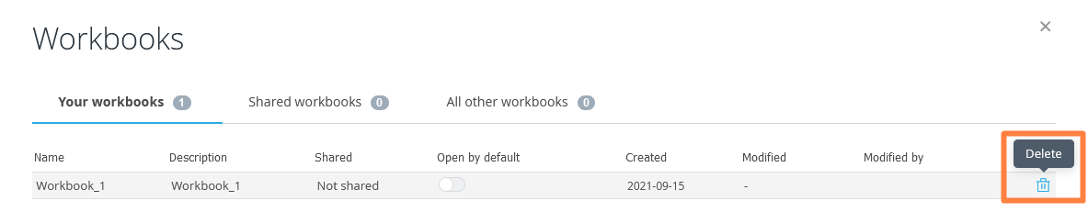

Export a Workbook

The current open workbook can be exported to Excel from the Workbook panel.
To make an export click the Export option in the Workbook panel and select export option.

Either you export all the sheets or just the selected sheets. You can also select if all the sheets online should be exported as separate sheets or if all sheets online should be merged into single sheet in the exported Excel file.

Here we see the export button, click this button to open the export panel.

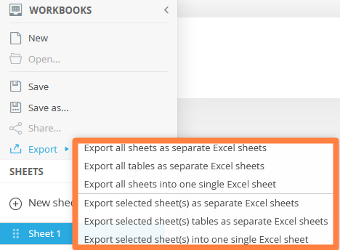

Share a workbook

If sharing is allowed the sharing of workbooks are made via the Sharing option in the Workbook panel. Sharing of Workbooks works in the same way as sharing Favorites which means that you can share to all users or selected users.

When sharing a workbook to all users only the users with access to all the items (Hierarchical filters, Filters and Variable subsets) in the Workbook can see and load the shared Favorite.
When sharing a Favorite to selected users you can only share to users with access to all the items in the shared Workbook.

Here we see the sharing option to the left and sharing panel to the right.
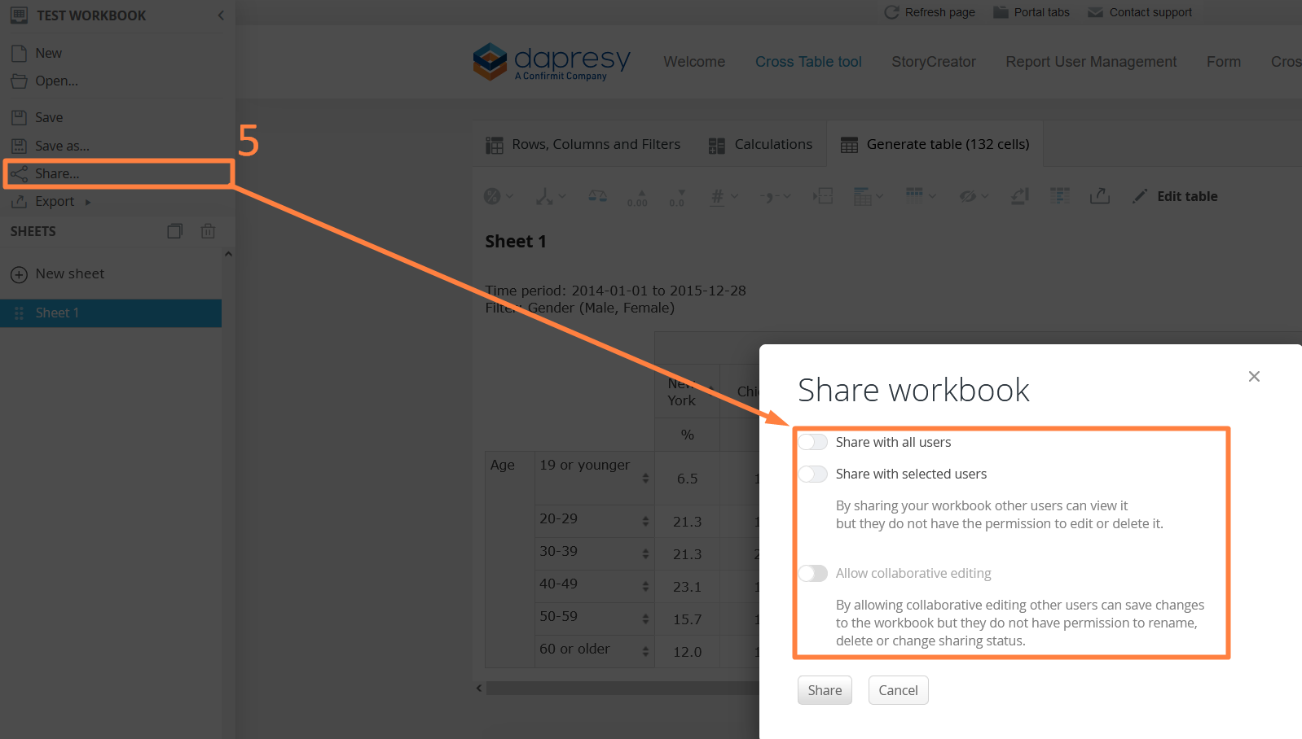

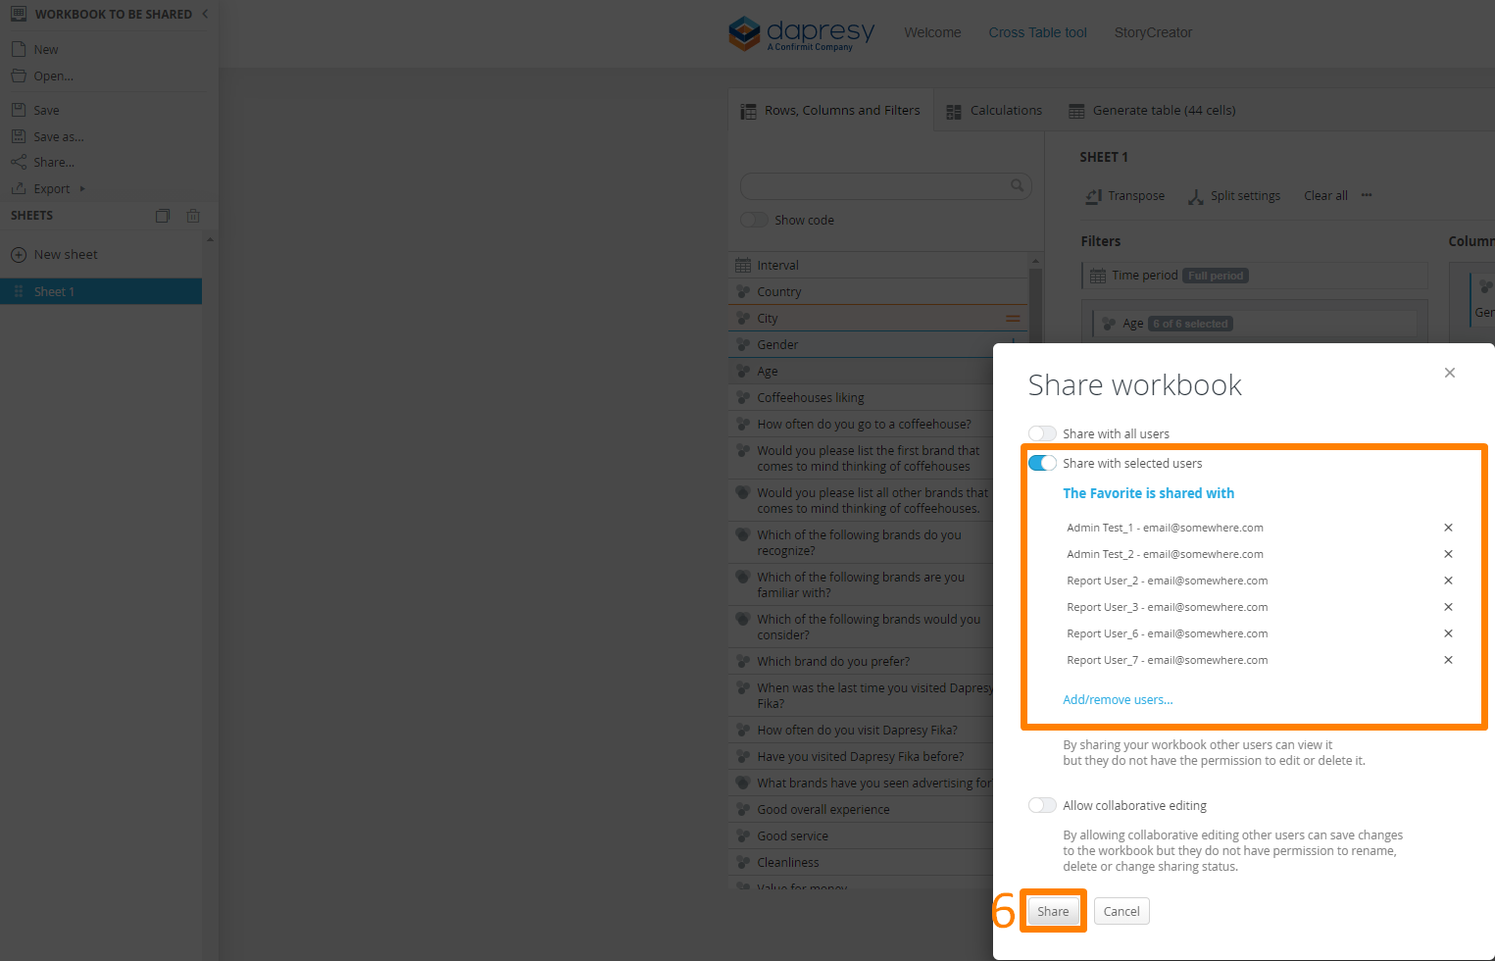

To open a Workbook shared by another user enter the Workbook panel and the second sheet which lists all the workbooks shared by other users. An Administrator user will see all the saved Workbooks in this list, even the non-shared workbooks.

Here we see how load a shared workbook.
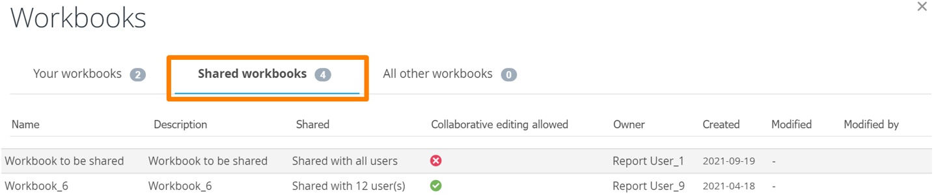

Toolbar in Cross table

Toolbar, with most used table settings, can be found in the result table for a more efficient workflow. You can easily update number of decimals, enable the base size, insert table breaks etc. when viewing the table without switching tab.

As a result of the Toolbar the Settings tab is no longer used in the Cross Table tool, the Base size selection settings have been moved into the Calculation tab and the rest of the settings are in the new toolbar.

Calculations

Standard calculations such as %, Count, Mean, Sum, etc. can be enabled in the Calculation menu, only calculation types applicable to the selected questions are shown in the menu.
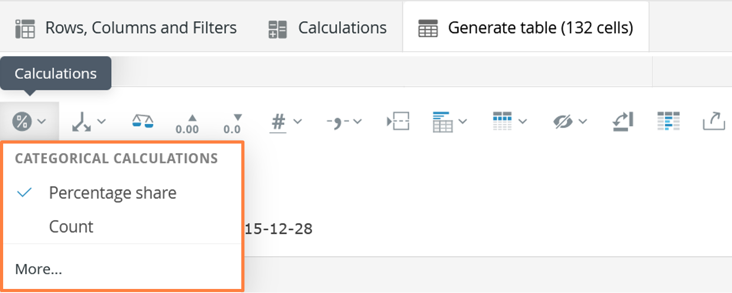

The more advanced calculations options such as Significance testing, Ranking, Correlation and Benchmarking are still set in the Calculations tab.
Split Settings

In the Splits menu select if splits should be nested or un-nested as well as if Totals and Subtotals should be displayed.

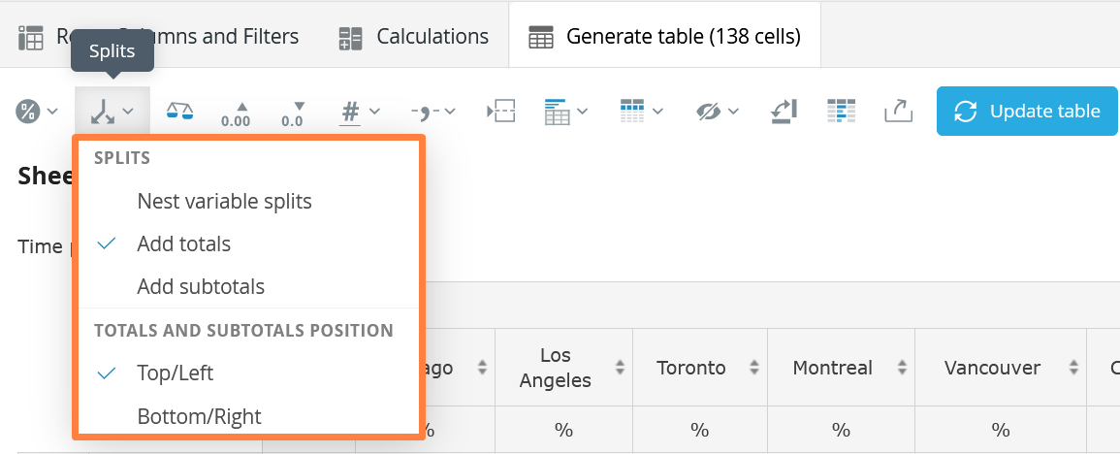

Weight

Weight can be turned on and off from the toolbar, if multiple weight variables are available choose which one to be used from here.
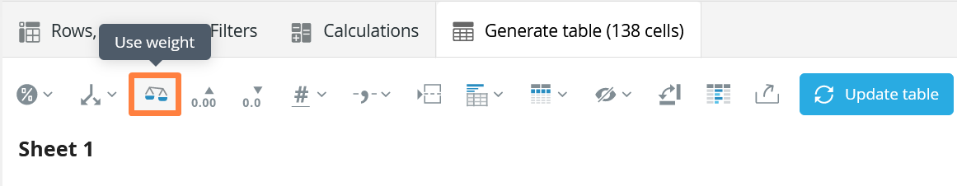

Note: In case where the user is not allowed to change between weighted and unweighted result the Weight option is not displayed in the toolbar

Number of decimals

Number of decimal places can be increased/decreased from the toolbar.
As different calculation types can have different number of decimals places applied the decimal setting in the toolbar increases/decreases each calculation type with one decimal place.
Example, the table displays count with 0 decimals and % with 1 decimal. By increasing the number of decimals with one place the count is displayed with 1 decimal and the % with 2 decimals.

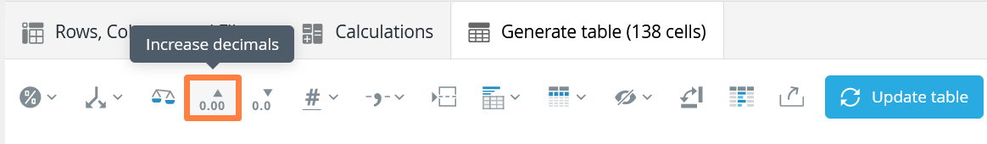

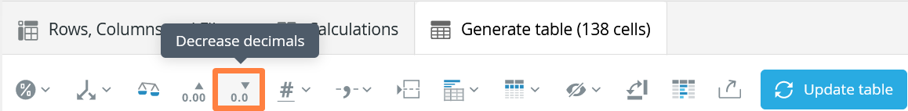

Note: The number of decimal setting in the toolbar effects the result only and not displayed base sizes.

Base Size
In the base size menu the base size is turned on and off and the position changed. The weighted base size options are only available when calculation is weighted.
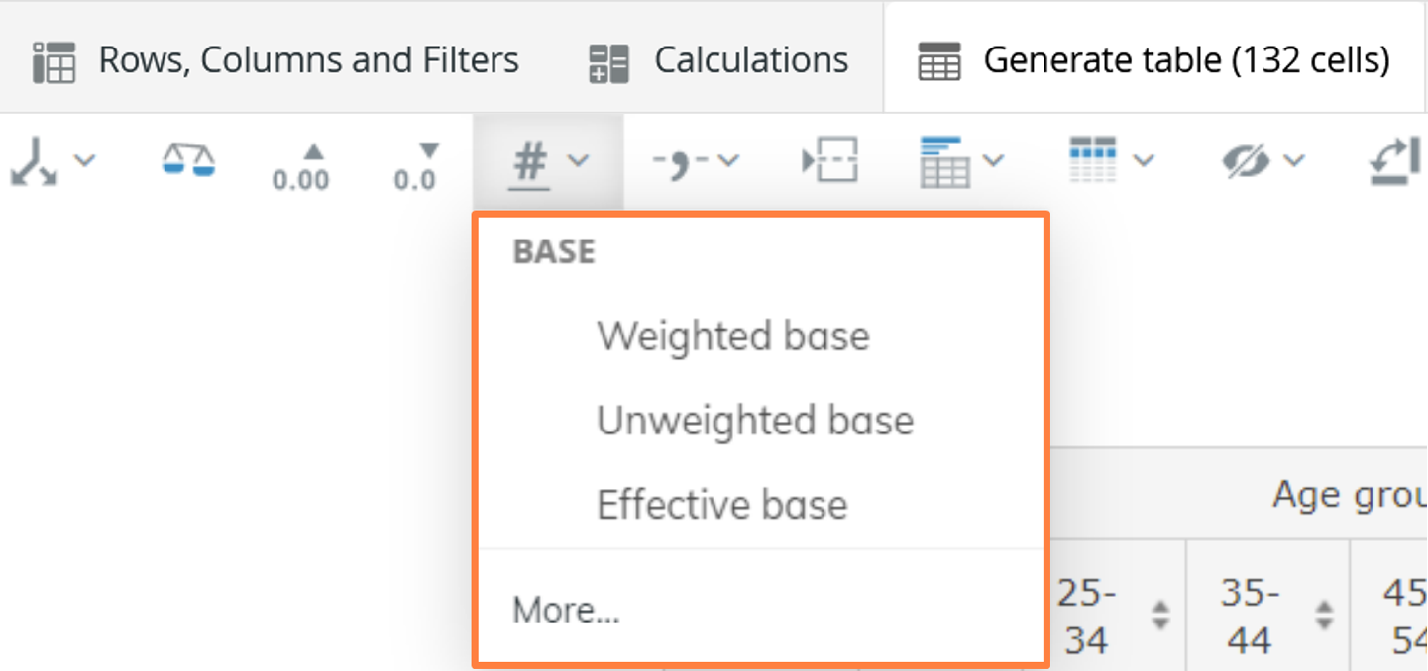

Decimal and thousand separators

The decimal and thousand separators can be changed from the toolbar as well.

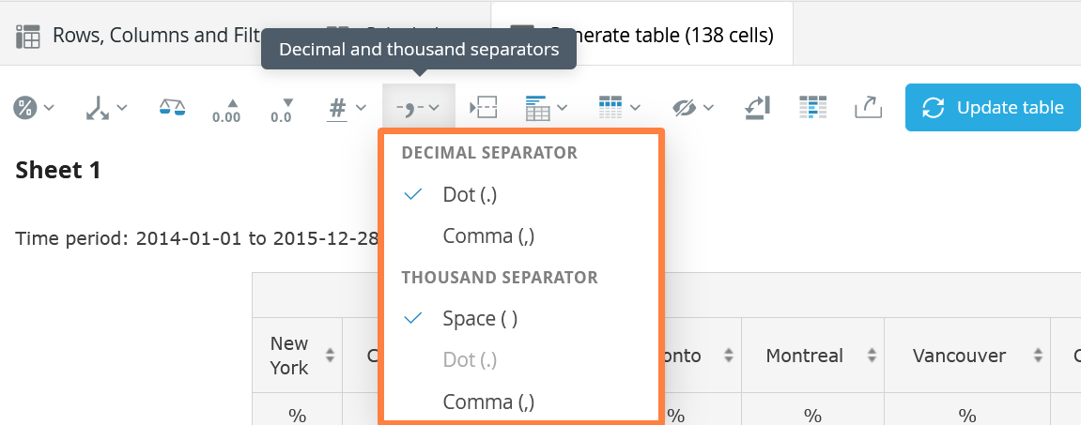

Table Breaks

From the toolbar Table breaks can be inserted between every question, all of the added table breaks can also be removed by clicking the same option.

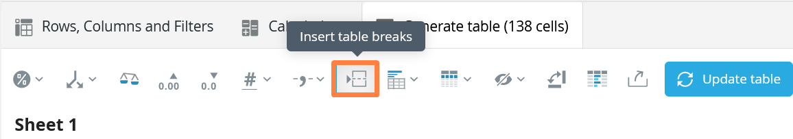

Note: If table breaks should be inserted in customized positions, this can be achieved in the “Rows, Columns and Filters” tab.

Table Key

In the Table key menu appropriate information can be selected, such as, applied filters and time period, to be shown above the table.

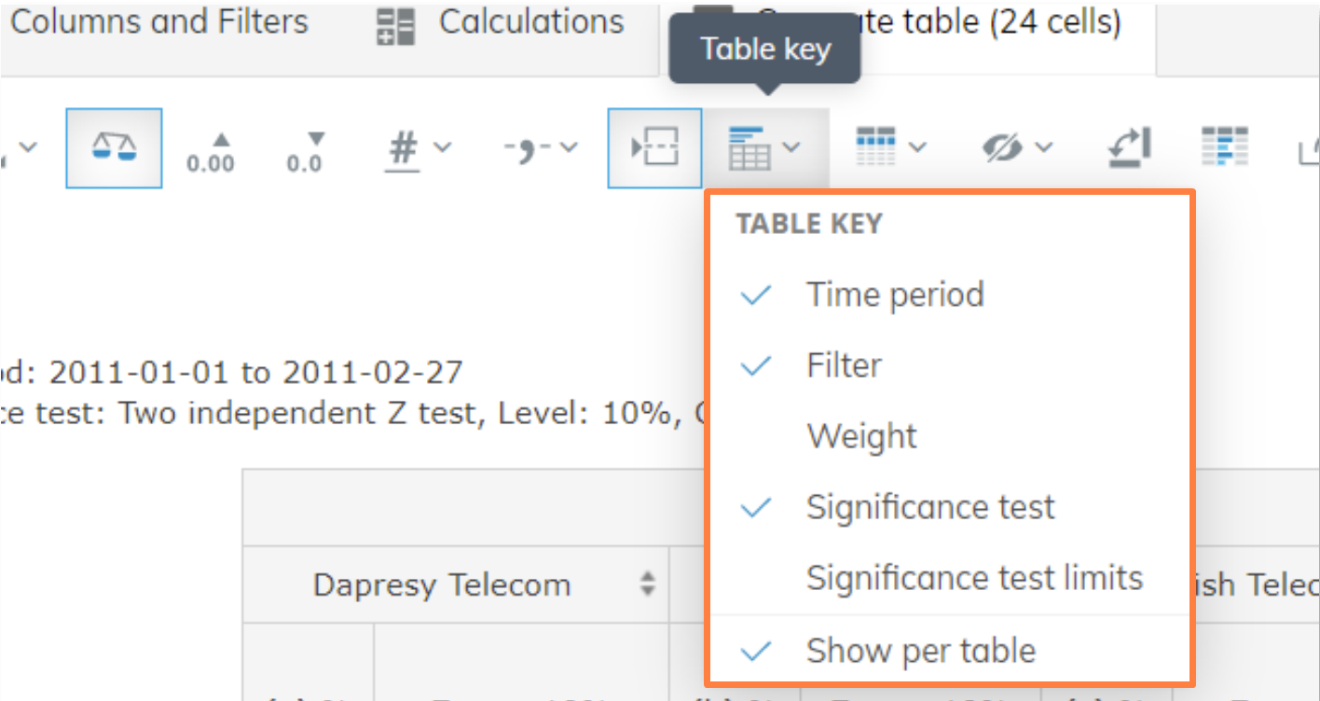

Displayed labels

Question and Split question texts can be turned on and off from the following option as seen below.

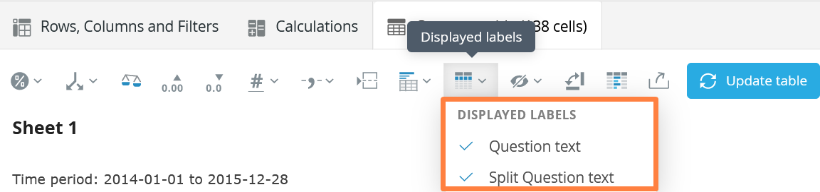

Note: the settings for hiding question and split question texts were previously located in the Settings tab which has been removed, these settings are now only available in the toolbar.

Hide empty series

In the Hide Empty series menu the settings for hiding date gaps, empty series and splits with "no data" are enabled and disabled.

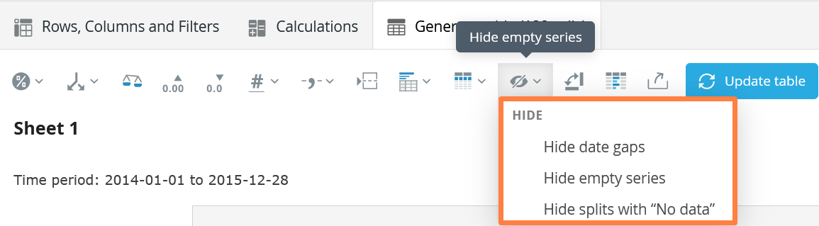

Note: the settings for hiding empty series were previously located in the Settings tab which has been removed, these settings are now only available in the toolbar.

Transpose

The transpose function to transpose rows and columns is now available in the toolbar.

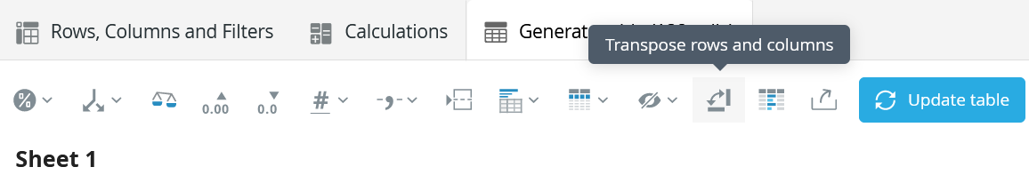

Formatting rules

The Formatting rules panel is also now opened from the new toolbar.

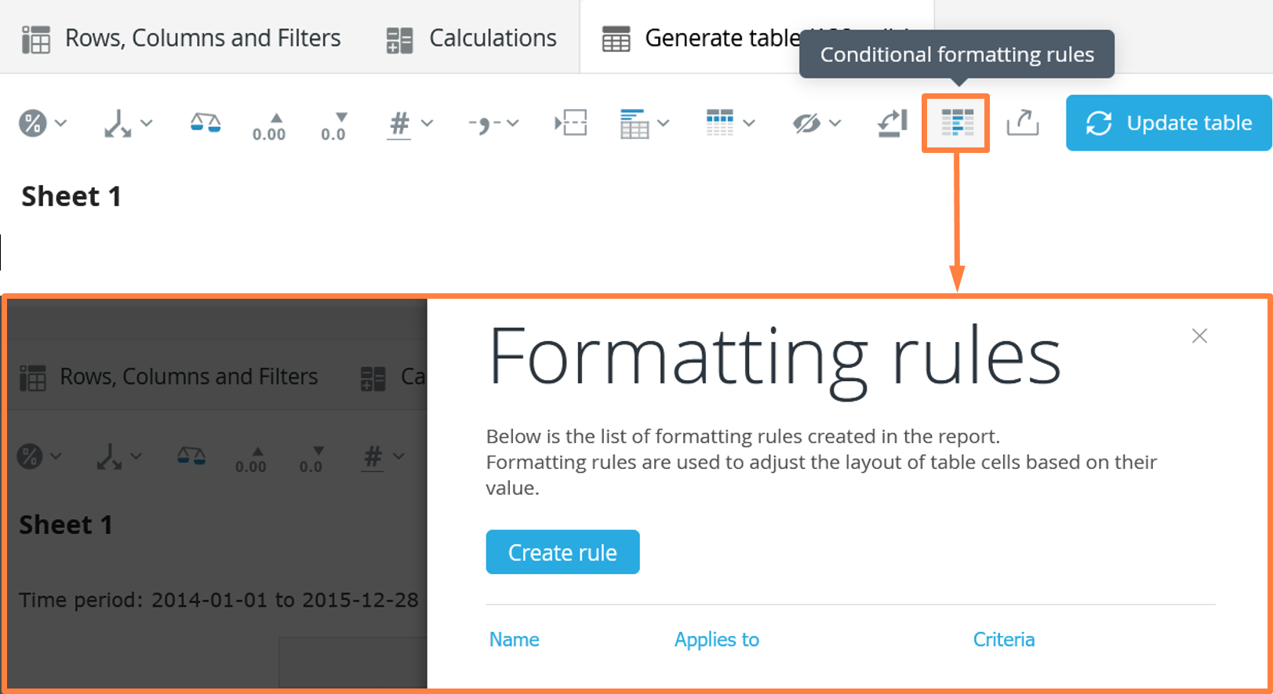

Note: The formatting rules panel were previously located in the Settings tab which has been removed, the Formatting rules panel can only be opened from the toolbar.

Export

The current sheet can be exported from the toolbar.

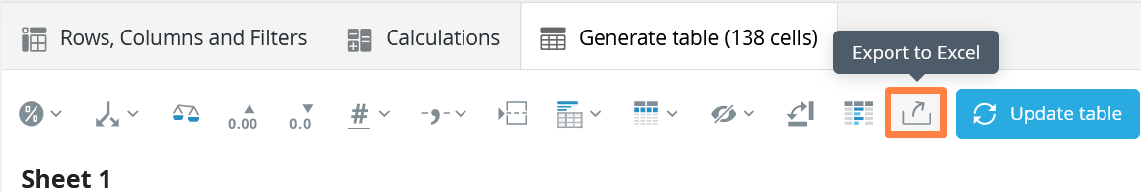

How to Add Table Brakes.

In order to add table brakes right click to access the context menu as seen below.

1. Select "Insert table brakes after every question"
2. Click the X (remove) button on individual brake line.

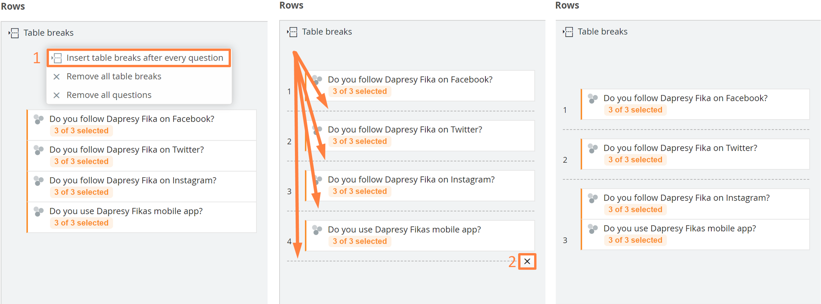

Now tables will be separated as per desired outcomes.

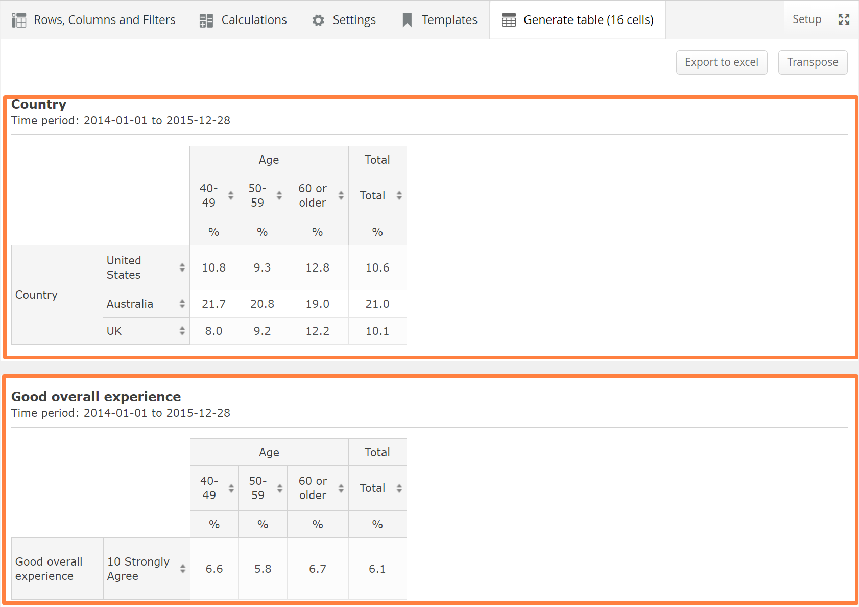

Alternatively, Right clicking on the question brings out the context menu where individual brakes can be added by insertion before or after the said question.

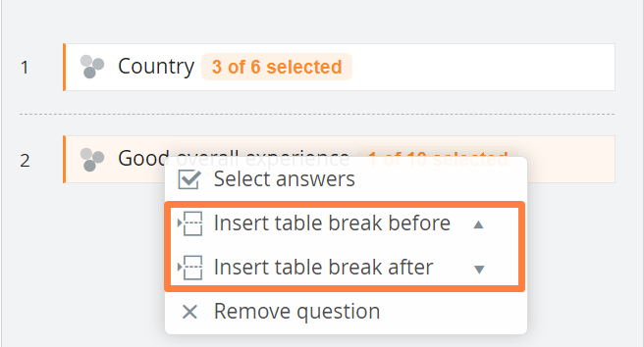
Note: To remove all table brakes use an option form the context menu as before

